Exam 4

Pregunta 1:**Incorrecto**

**​ You decide to buy a reserved instance for a term of one year. Which option provides the largest total discount?**

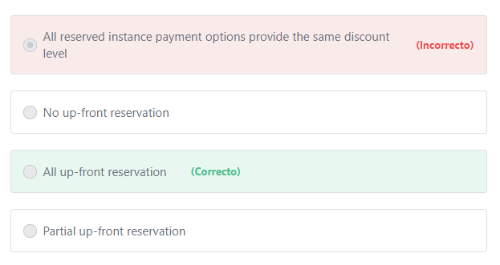

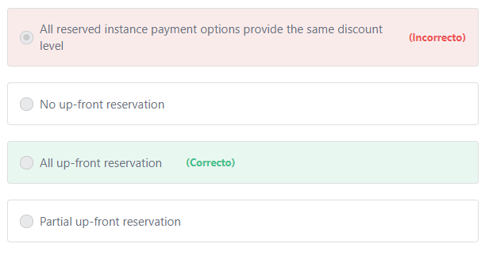Principio del formulario

**Explicación**

            There are three payment options available when purchasing reserved instances:

1- No up-front

2- Partial up-front

3- All up-front.

The general rule is: “the more you spend upfront, the more discounts you get."

       With the All Upfront option, you pay for the entire Reserved Instance term with one upfront payment. This option provides you with the largest discount compared to On-Demand instance pricing.

***The other options are incorrect:***

***"No up-front reservation" is incorrect.***The No up-front option does not require any upfront payment and provides a discounted hourly rate for the duration of the term. But the price will be higher compared to other options because there was no up-front payment.

***"Partial up-front reservation" is incorrect.*** With the Partial Upfront option, you make a low upfront payment and are then charged a discounted hourly rate for the instance for the duration of the Reserved Instance term. The price of the instance will be more than the price of the instance purchased using the “All up-front option” because, with the Partial up-front option, you pay less up-front. Hence, the correct answer is All up-front.

**References:**

<https://aws.amazon.com/ec2/pricing/reserved-instances/pricing/>

Final del formulario

Principio del formulario

Pregunta 2:**Incorrecto**

**Which of the following can be used to enable the Virtual Multi-Factor Authentication? (Choose TWO)**

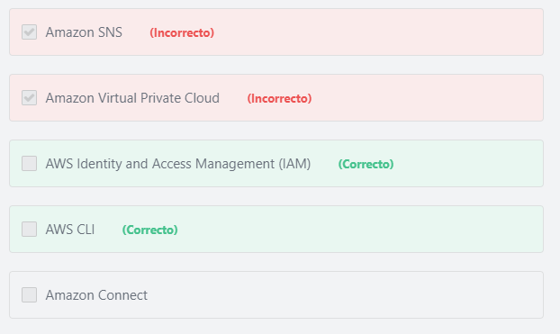

Final del formulario

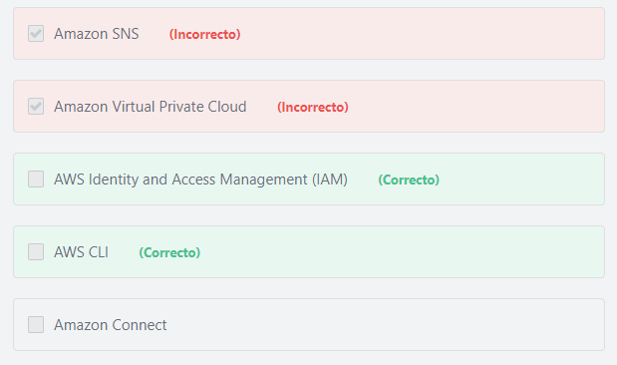Principio del formulario

**Explicación**

            You can use either the AWS IAM console or the AWS CLI to enable a virtual MFA device for an IAM user in your account.

***The other options are incorrect:***

***Amazon SNS is incorrect.***Amazon Simple Notification Service (SNS) is a fully managed pub/sub messaging service.

***Amazon Virtual Private Cloud is incorrect.***Amazon Virtual Private Cloud allows you to define a virtual network in AWS.

***Amazon Connect is incorrect.*** Amazon Connect is a cloud-based contact center service.

**References:**

<https://docs.aws.amazon.com/IAM/latest/UserGuide/id_credentials_mfa_enable_virtual.html>

Final del formulario

Principio del formulario

Pregunta 3:**Correcto**

**Which of the following is true regarding the AWS availability zones and edge locations?**

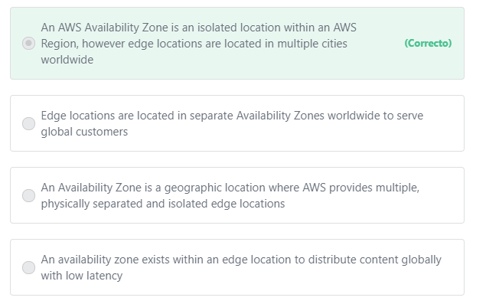

Final del formulario

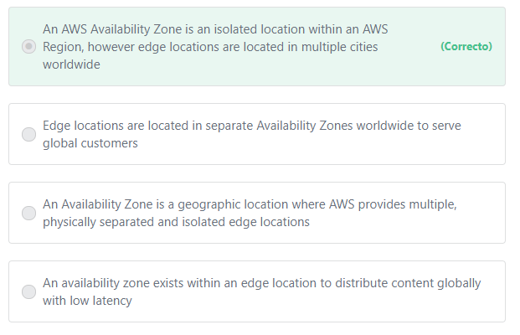Principio del formulario

**Explicación**

           In AWS, each Region has multiple, isolated locations known as Availability Zones. Availability Zones consist of one or more discrete data centers, each with redundant power, networking, and connectivity, housed in separate facilities.

           Edge locations may or may not exist within a region. They are located in most major cities around the world. Edge locations are specifically used by CloudFront (CDN) to distribute content to global users with low latency.

***The other options are incorrect:***

***"An availability zone exists within an edge location to distribute content globally with low latency" is incorrect.***An availability zone exists within an AWS Region, not within an edge location

***"Edge locations are located in separate Availability Zones worldwide to serve global customers" is incorrect.*** Edge locations are located in most major cities around the world. Edge locations may or may not exist within a given AWS Region.

***"An Availability Zone is a geographic location where AWS provides multiple, physically separated and isolated edge locations" is incorrect.***An availability zone exists within an AWS Region. Edge locations are located in most major cities around the world. Edge locations may or may not exist within a given AWS Region.

**References:**

<https://docs.aws.amazon.com/AWSEC2/latest/UserGuide/using-regions-availability-zones.html>

Final del formulario

Principio del formulario

Pregunta 4:**Correcto**

**​ What is the name of the DynamoDB replication capability that provides fast read \ write performance for globally deployed applications?**

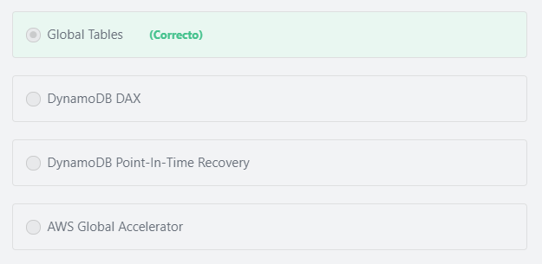

Final del formulario

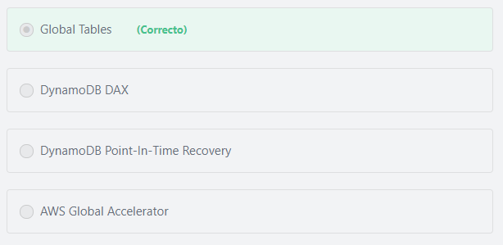Principio del formulario

**Explicación**

             DynamoDB global tables are ideal for massively scaled applications with globally dispersed users. Global tables provide automatic replication to AWS Regions world-wide. They enable you to deliver low-latency data access to your users no matter where they are located.

***The other options are incorrect:***

***"DynamoDB DAX" is incorrect.***DynamoDB Accelerator (DynamoDB DAX) is an in-memory cache for DynamoDB that reduces response times from milliseconds to microseconds.

***"AWS Global Accelerator" is incorrect.***AWS Global Accelerator is not a DynamoDB feature. AWS Global Accelerator is a network service that enables organizations to seamlessly route traffic to multiple regions and improve availability and performance for their local and global end-users. AWS Global Accelerator uses AWS’s vast, highly-available global network to direct internet traffic from your users to your applications running in disparate AWS regions. With AWS Global Accelerator, your users are directed to your workload based on their geographic location, application health, and weights that you can configure. Regardless of where your users are located, AWS Global Accelerator intelligently routes traffic to the endpoint that provides the best application performance and availability to your users.

***"***​***DynamoDB Point-In-Time Recovery" is incorrect.*** DynamoDB point-in-time recovery (PITR) is used to back up your data with per-second granularity and restore to any single second from the time it was enabled up to the prior 35 days. DynamoDB PITR works as additional insurance against accidental loss of data.

**References:**

<https://d1.awsstatic.com/whitepapers/aws_pricing_overview.pdf>    page 16

<https://docs.aws.amazon.com/amazondynamodb/latest/developerguide/GlobalTables.html>

Final del formulario

Principio del formulario

Pregunta 5:**Incorrecto**

**Which AWS service enables you to quickly purchase and deploy SSL/TLS certificates?**

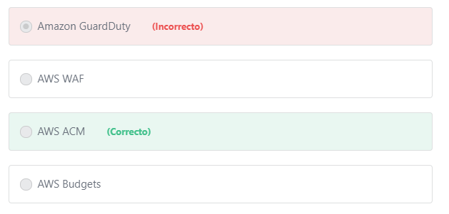

Final del formulario

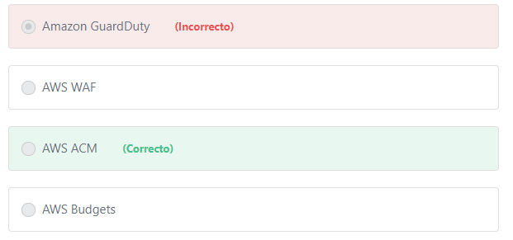Principio del formulario

**Explicación**

            AWS Certificate Manager (AWS ACM) is a service that lets you easily provision, manage, and deploy public and private Secure Sockets Layer/Transport Layer Security (SSL/TLS) certificates for use with AWS services and your internal connected resources. SSL/TLS certificates are used to secure network communications and establish the identity of websites over the Internet as well as resources on private networks.

           AWS Certificate Manager removes many of the time-consuming and error-prone steps to acquire an SSL/TLS certificate for your website or application. With a few clicks in the AWS Management Console, you can request a trusted SSL/TLS certificate from AWS. Once the certificate is created, AWS Certificate Manager takes care of deploying certificates to help you enable SSL/TLS for your website or application.

***The other options are incorrect:***

***AWS WAF is incorrect.***AWS WAF is a web application firewall that helps protect your web applications or APIs against common web exploits that may affect availability, compromise security, or consume excessive resources. AWS WAF gives you control over how traffic reaches your applications by enabling you to create security rules that block common attack patterns, such as SQL injection or cross-site scripting, and rules that filter out specific traffic patterns you define.

***Amazon Guard​Duty is incorrect.***Amazon GuardDuty is a threat detection service that continuously monitors for malicious activity and unauthorized behavior to protect your AWS accounts and workloads.

***AWS Budgets is incorrect.*** AWS Budgets enables you to set custom budgets that alert you when you exceed your budgeted thresholds

**References:**

<https://d1.awsstatic.com/whitepapers/aws-overview.pdf>    page 80

Final del formulario

Principio del formulario

Pregunta 6:**Incorrecto**

**What are the capabilities of AWS X-Ray? (Choose TWO)**

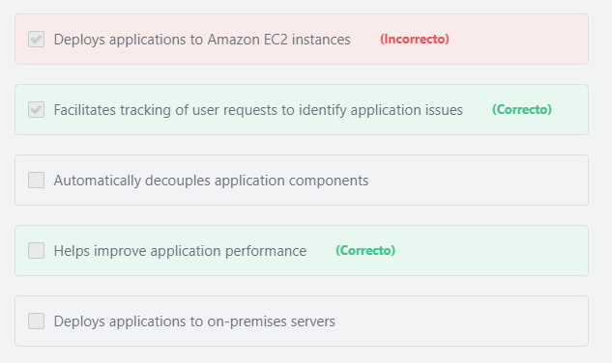

Final del formulario

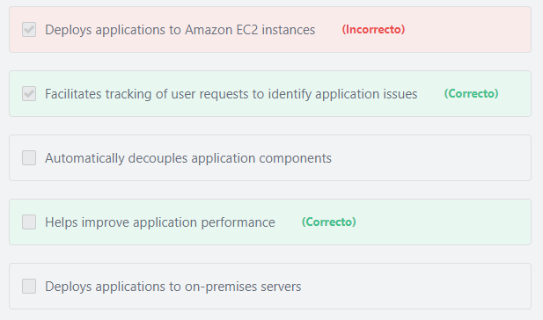Principio del formulario

**Explicación**

Benefits of AWS X-Ray include:

1- Review request behavior:

AWS X-Ray traces user requests as they travel through your entire application. It aggregates the data generated by the individual services and resources that make up your application, providing you an end-to-end view of how your application is performing.

2- Discover application issues:

With AWS X-Ray, you can glean insights into how your application is performing and discover root causes. With X-Ray’s tracing features, you can follow request paths to pinpoint where in your application and what is causing performance issues.

3- Improve application performance

AWS X-Ray helps you identify performance bottlenecks. X-Ray’s service maps let you see relationships between services and resources in your application in real time. You can easily detect where high latencies are occurring, visualize node and edge latency distribution for services, and then drill down into the specific services and paths impacting application performance.

***The other options are incorrect.***

***"Deploys applications to Amazon EC2 instances" is incorrect.***AWSX-Ray does not deploy applications. The AWS services that can help you deploy your applications to Amazon EC2 instances include: AWS Elastic Beanstalk, AWS CloudFormation, AWS CodeDeploy and AWS OpsWorks.

***"Deploys applications to on-premises servers" is incorrect.***AWSX-Ray does not deploy applications. The AWS services that can help you deploy your applications to on-premises serversinclude: AWS CodeDeploy and AWS OpsWorks.

Note: You cannot use AWS Elastic Beanstalk or AWS CloudFormation to deploy your applications to on-premises servers.

***"Enables you to decouple your application components" is incorrect.***AWSX-Ray does not automatically decouple application components, and no AWS Services automatically decouple application components. The AWS services that can help you decouple your applicationsinclude: Amazon Simple Queue Service (SQS) and Amazon Simple Notification Service (SNS).

**References:**

<https://aws.amazon.com/xray/>

<https://d0.awsstatic.com/whitepapers/overview-of-deployment-options-on-aws.pdf>

<https://aws.amazon.com/about-aws/whats-new/2014/12/08/aws-opsworks-supports-existing-ec2-instances-and-on-premises-servers/>

<https://aws.amazon.com/blogs/aws/aws-codedeploy-update-new-support-for-on-premises-instances/>

Final del formulario

Principio del formulario

Pregunta 7:**Incorrecto**

**​Which AWS Service helps enterprises extend their on-premises storage to AWS in a cost-effective manner?**

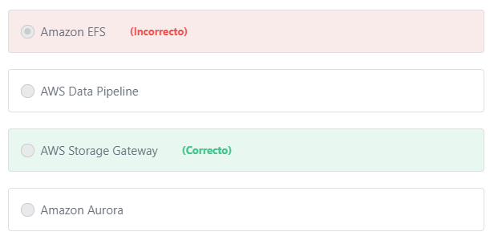

Final del formulario

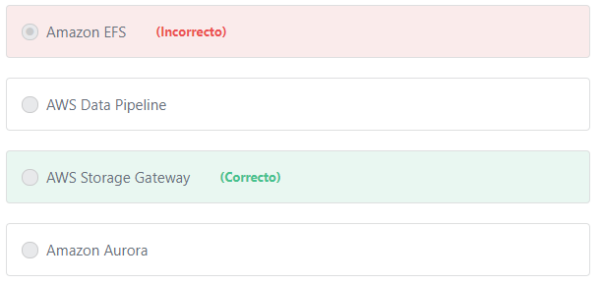Principio del formulario

**Explicación**

          Enterprises can extend their on-premises storage to AWS Cloud for long-term backup retention and archiving, optimizing costs and increasing resilience and availability. AWS Storage Gateway is a hybrid storage service that enables on-premises applications to seamlessly use AWS cloud storage. Enterprises can use the service for backup and archiving, disaster recovery, cloud data processing, storage tiering, and migration. The storage gateway connects to AWS storage services, such as Amazon S3, Amazon S3 Glacier, Amazon S3 Glacier Deep Archive, Amazon EBS, and AWS Backup, providing storage for files, volumes, snapshots, and virtual tapes in AWS.

***The other options are incorrect:***

***Amazon Aurora is incorrect.*** Amazon Aurora is a MySQL and PostgreSQL-compatible relational database service.

***Amazon EFS is incorrect.*** Amazon Elastic File System (Amazon EFS) provides fully managed elastic NFS file system for use with AWS Cloud services and on-premises resources. It is built to scale on demand to petabytes without disrupting applications, growing and shrinking automatically as you add and remove files, eliminating the need to provision and manage capacity to accommodate growth. Although EFS can be used in hybrid environments, it is not as cost-effective as Storage Gateway.

***AWS Data Pipeline is incorrect.*** AWS Data Pipeline is a web service that helps customers reliably process and move data between different AWS compute and storage services, as well as on-premises data sources. AWS Data Pipeline is not a storage service.

**References:**

<https://aws.amazon.com/storagegateway/>

Final del formulario

Principio del formulario

Pregunta 8:**Incorrecto**

**Which AWS Service offers a filesystem that can be mounted concurrently from multiple EC2 instances?**

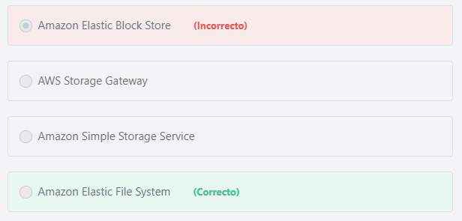

Final del formulario

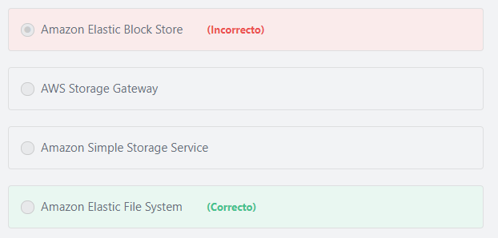Principio del formulario

**Explicación**

             Amazon Elastic File System (Amazon EFS) provides simple, scalable file storage for use with Amazon EC2 instances in the AWS Cloud. Amazon EFS is easy to use and offers a simple interface that allows you to create and configure file systems quickly and easily. With Amazon EFS, storage capacity is elastic, growing and shrinking automatically as you add and remove files, so your applications have the storage they need, when they need it. When mounted on Amazon EC2 instances, an Amazon EFS file system provides a standard file system interface and file system access semantics, allowing you to seamlessly integrate Amazon EFS with your existing applications and tools. Multiple EC2 instances can access an Amazon EFS file system at the same time, allowing Amazon EFS to provide a common data source for workloads and applications running on more than one EC2 instance.

***The other options are incorrect:***

***"AWS Storage Gateway" is incorrect.*** AWS Storage Gateway is a hybrid storage service that enables your on-premises applications to seamlessly use AWS cloud storage.

***"Amazon Elastic Block Store" is incorrect.*** An Amazon Elastic Block Store (Amazon EBS) volume can be attached to only one instance at a time.

***"Amazon Simple Storage Service" is incorrect.***Amazon Simple Storage Service (Amazon S3) is an object storage service, and cannot serve as a filesystem that is mounted to Amazon EC2 instances.

**References:**

<https://d1.awsstatic.com/whitepapers/aws-overview.pdf>       page 85

Final del formulario

Principio del formulario

Pregunta 9:**Incorrecto**

**Which of the following is NOT a factor when estimating the costs of Amazon EC2? (Choose TWO)**

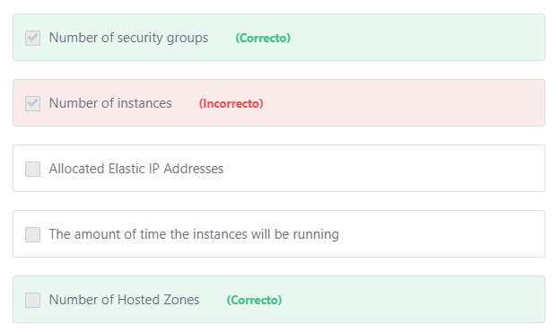

Final del formulario

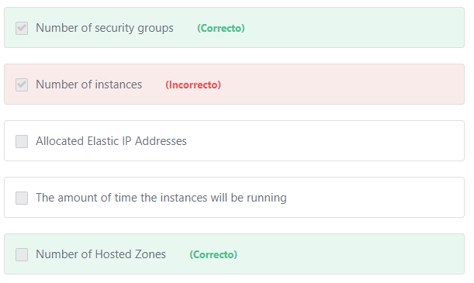Principio del formulario

**Explicación**

There are no associated costs for "EC2 Security Groups" or "Hosted Zones" and thus are correct answers.

EC2 Security groups are free to use.

Hosted Zones are not free, but they are not related to Amazon EC2 costs. Hosted Zones is one of the factors of the Amazon Route 53 costs.

***The other options represent factors you should consider when estimating the cost of Amazon EC2 and are therefore incorrect.***

         When you begin to estimate the cost of using Amazon EC2, consider the following:

1- Clock hours of server time: The amount of time that the instances will be running has a direct bearing on the overall price, as EC2 instances are charged either by the hour or by the second, depending on which AMI is used.

2- Instance type: Amazon EC2 provides a wide selection of instance types optimized to fit different use cases. Instance types comprise varying combinations of CPU, memory, storage, and networking capacity.

3- Pricing model: On-Demand, Reserved, Spot and Dedicated

4- Number of instances: You can provision multiple instances of your Amazon EC2 and Amazon EBS resources to handle peak loads.

5- Load balancing: The number of hours the Elastic Load Balancer runs and the amount of data it processes contribute to the EC2 monthly cost.

6- Elastic IP addresses: You can have one Elastic IP (EIP) address associated with a running instance at no charge. Additional Elastic IPs are not free.

7- Operating systems and software packages: Operating system prices are included in instance prices, unless you choose to bring your own licenses.

**References:**

<https://d1.awsstatic.com/whitepapers/aws_pricing_overview.pdf>    page 8

Final del formulario

Principio del formulario

Pregunta 10:**Correcto**

**Which of the following is a type of MFA device that customers can use to protect their AWS resources?**

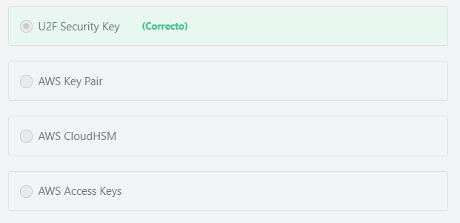

Final del formulario

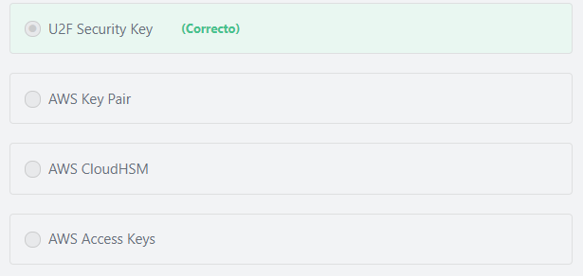Principio del formulario

**Explicación**

           AWS multi-factor authentication (AWS MFA) provides an extra level of security that customers can apply to their AWS environment. With MFA enabled, when a user signs in to an AWS website, they will be prompted for their user name and password (the first factor—what they know), as well as for an authentication code from their AWS MFA device (the second factor—what they have). Taken together, these multiple factors provide increased security for the AWS account resources. AWS supports several MFA device options including **Virtual MFA devices, Universal 2nd Factor**(**U2F) security key, and Hardware MFA devices.**

***The other options are incorrect:***

***"Access Keys" is incorrect.***Access keys are long-term credentials for an IAM user or the AWS account root user. Customers can use access keys to sign programmatic requests to the AWS CLI or AWS API (directly or using the AWS SDK).

***"AWS*** ***Key Pair" is incorrect.***The AWS Key pair cryptography enables customers to securely access their Amazon EC2 instances using a private key instead of a password.

***"AWS CloudHSM" is incorrect.*** AWS CloudHSM is a cloud-based hardware security module (HSM) that enables customers to easily generate and use their own encryption keys on the AWS Cloud.

**References:**

<https://docs.aws.amazon.com/IAM/latest/UserGuide/id_credentials_mfa.html>

Final del formulario

Principio del formulario

Pregunta 11:**Incorrecto**

**Which of the following are examples of AWS-managed databases? (Choose TWO)**

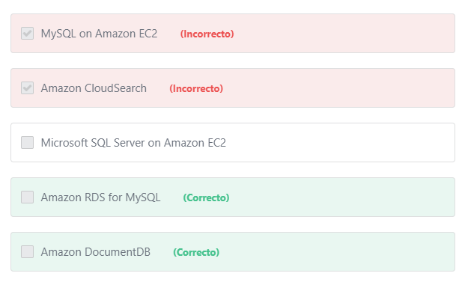

Final del formulario

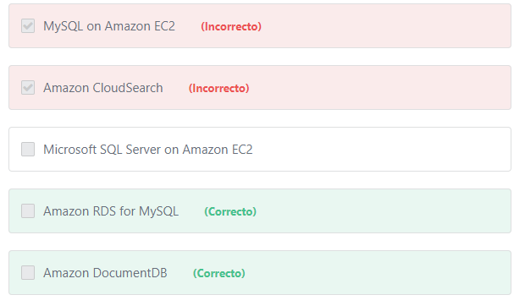Principio del formulario

**Explicación**

         AWS-managed databases are a database as a service offering from AWS where AWS manages the underlying hardware, storage, networking, backups, and patching. Users of AWS-managed databases simply connect to the database endpoint, and do not have to concern themselves with any aspects of managing the database. Examples of AWS-managed databases include: Amazon RDS ( Amazon Aurora, PostgreSQL, MySQL, MariaDB, Oracle Database, and SQL Server), Amazon DocumentDB, Amazon Redshift, and Amazon DynamoDB.

***The other options are incorrect:***

***"Microsoft SQL Server on Amazon EC2" and "MySQL on Amazon EC2" are incorrect.***Microsoft SQL Server on Amazon EC2 and MySQL on Amazon EC2 are customer-managed databases, not AWS-managed databases. Any database that is running on EC2 is managed by the customer, and not by AWS.

**Note:** Customers can install and run any database engine - or any Software - on Amazon EC2, but in this case, the customer is responsible for managing the software, not AWS.

***"Amazon CloudSearch" is incorrect.*** Amazon CloudSearch is a managed service in the AWS Cloud that makes it simple and cost-effective to set up, manage, and scale a search solution for your website or application.

**References:**

<https://aws.amazon.com/documentdb/>

<https://aws.amazon.com/rds/mysql/>

<https://aws.amazon.com/sql/>

<https://aws.amazon.com/rds/mysql/what-is-mysql/>

Final del formulario

Principio del formulario

Pregunta 12:**Correcto**

**A company’s AWS workflow requires that it periodically perform large-scale image and video processing jobs. The customer is seeking to minimize cost and has stated that the amount of time it takes to process these jobs is not critical, but that cost minimization is the most important factor in designing the solution. Which EC2 instance class is best suited for this processing?**

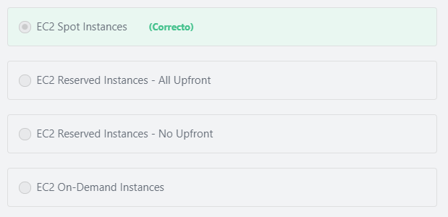

Final del formulario

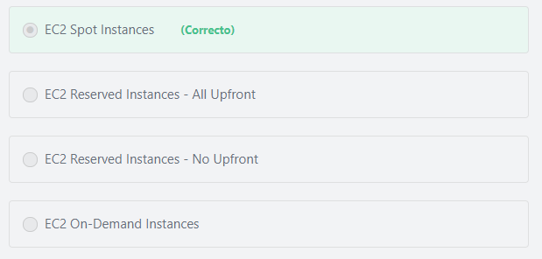Principio del formulario

**Explicación**

           A Spot Instance is an unused EC2 instance that is available for less than the On-Demand price. Because Spot Instances enable customers to request unused EC2 instances at steep discounts, customers can lower their Amazon EC2 costs significantly. Spot Instances run whenever capacity is available, and the maximum price per hour for the request exceeds the Spot price. The risk with Spot instances is that a running instance can be interrupted due to changes in demand and pricing for a specific class of Spot instances, as there is no guarantee of availability at any time. Spot Instances are well-suited for data analysis, batch jobs, background processing, and optional tasks, as well as for workloads that are not time critical.

***The other options are incorrect:***

***"EC2 On-Demand Instances" is incorrect.***The Spot option provides discounts up to 90% off compared to the On-Demand price, making this option less cost effective than the Spot Instance option.

***"EC2 Reserved Instances - All Upfront" and "​EC2 Reserved Instances - No Upfront"are incorrect.*** Use of reservations means that the customer will be charged the agreed upon Reserved Instance hourly rate irrespective of if the instance is running or not. Because these jobs are both periodic and non-time sensitive, Spot Instances are better suited for the task, and they offer a lower price point than Reserved Instances.

**References:**

<https://docs.aws.amazon.com/AWSEC2/latest/UserGuide/using-spot-instances.html>

Final del formulario

Principio del formulario

Pregunta 13:**Incorrecto**

**A customer is planning to migrate their Microsoft SQL Server databases to AWS. Which AWS Services can the customer use to run their Microsoft SQL Server database on AWS? (Choose TWO)**

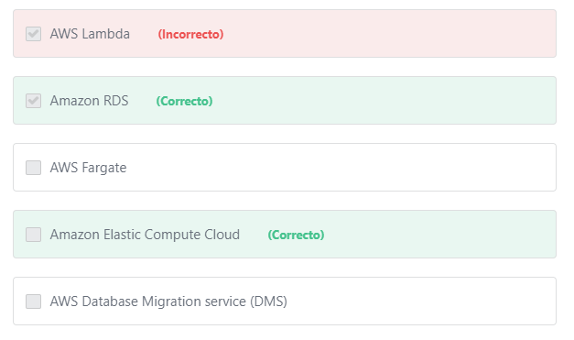

Final del formulario

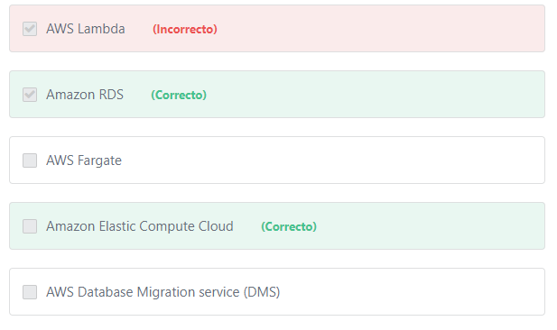Principio del formulario

**Explicación**

          Amazon Web Services offers the flexibility to run Microsoft SQL Server as either a self-managed component inside of EC2, or as a managed service via Amazon RDS. Using SQL Server on Amazon EC2 gives customers complete control over the database, just like when it’s installed on-premises. Amazon RDS is a fully managed service where AWS manages the maintenance, backups, and patching.

***The other options are incorrect:***

***AWS Database Migration Service (DMS) is incorrect.***AWS Database Migration service (DMS) is an AWS Service designed to assist customers in migrating their databases to AWS quickly and securely. The source database remains fully operational during the migration, minimizing downtime to applications that rely on the database. The AWS Database Migration Service can migrate your data to and from most widely used commercial and open-source databases. It is important to note that while DMS can be used to **migrate the data**, it has nothing to do with **running** the database.

***AWS Fargate is incorrect.*** AWS Fargate is a compute engine for Amazon Elastic Container Service (ECS) that allows customers to run containers without having to manage servers or clusters.

***AWS Lambda is incorrect.*** AWS Lambda is a compute service that lets you run code without provisioning or managing servers (serverless).

**References:**

<https://aws.amazon.com/sql/>

Final del formulario

Principio del formulario

Pregunta 14:**Incorrecto**

**Which of the following services can be used to monitor the HTTP and HTTPS requests that are forwarded to Amazon CloudFront?**

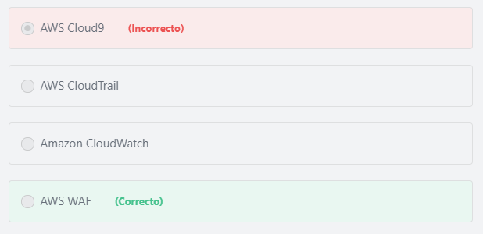

Final del formulario

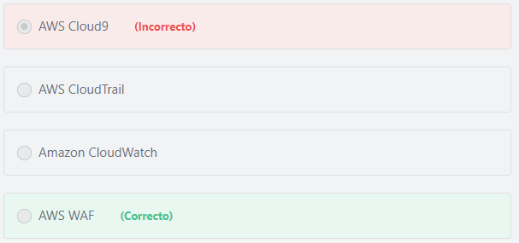Principio del formulario

**Explicación**

          AWS WAF is a web application firewall that lets customers monitor the HTTP and HTTPS requests that are forwarded to Amazon CloudFront or an Application Load Balancer. AWS WAF also lets customers control access to their content by defining customizable web security rules.

***The other options are incorrect:***

***AWS CloudTrail is incorrect.***AWS CloudTrail is a logging service that tracks and records user activity and API usage for audit purposes.

***Amazon CloudWatch is incorrect.*** Amazon CloudWatch is used to monitor the utilization of the AWS cloud resources (such as Amazon EC2 instances, Amazon DynamoDB tables, and Amazon RDS DB instances), as well as custom metrics generated by applications and services.

***AWS Cloud9 is incorrect.*** AWS Cloud9 is a cloud-based integrated development environment (IDE) that lets customers write, run, and debug code with just a browser. It includes a code editor, debugger, and terminal. Cloud9 comes prepackaged with essential tools for popular programming languages, including JavaScript, Python, PHP, and more, so you don’t need to install files or configure your development machine to start new projects.

**References:**

<https://aws.amazon.com/waf/>

Final del formulario

Principio del formulario

Pregunta 15:**Correcto**

**Which AWS Service is used to manage the keys used to encrypt customer data?**

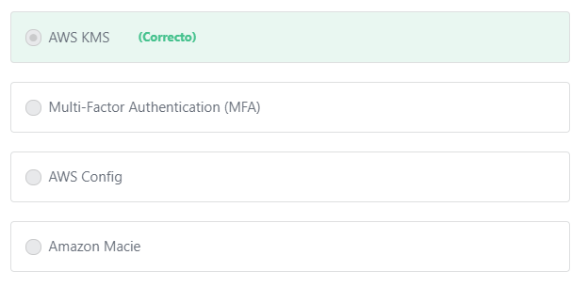

Final del formulario

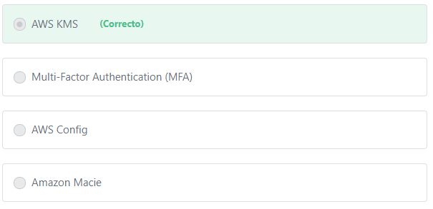Principio del formulario

**Explicación**

        AWS Key Management Service (AWS KMS) is a managed service that enables customers to easily create and control the keys used for cryptographic operations. The service provides a highly available key generation, storage, management, and auditing solution for customers to encrypt or digitally sign data within their applications or to control the encryption of data across AWS services.

***The other options are incorrect:***

***"AWS Config" is incorrect.***AWS Config is a fully managed service that provides customers with an AWS resource inventory, configuration history, and configuration change notifications to enable security and governance. AWS Config is not a key management service.

***"Multi-Factor Authentication (MFA)" is incorrect.***While MFA can help customers protect their data, MFA is not used to store  or manage encryption keys***.***

***"Amazon Macie" is incorrect.*** Amazon Macie is a security service that uses machine learning to automatically discover, classify, and protect sensitive data in AWS. Amazon Macie recognizes sensitive data such as personally identifiable information (PII) or intellectual property, and provides customers with dashboards and alerts that give visibility into how this data is being accessed or moved. Amazon Macie is not a key management service.

**References:**

<https://aws.amazon.com/kms/>

Final del formulario

Principio del formulario

Pregunta 16:**Incorrecto**

**​ Which of the following AWS offerings are serverless services? (Choose TWO)**

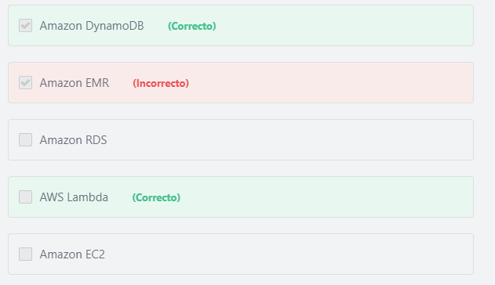

Final del formulario

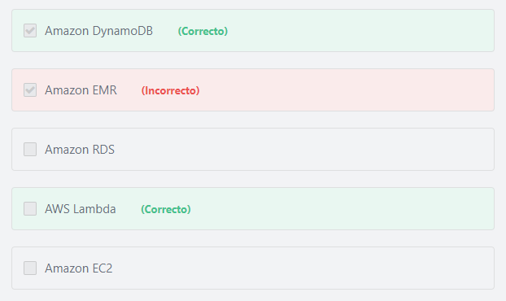Principio del formulario

**Explicación**

         AWS Lambda is a compute service that lets customers run code without provisioning or managing servers. AWS Lambda executes code only when needed and scales automatically, from a few requests per day to thousands per second.

         With DynamoDB, there are no servers to provision, patch, or manage and no software to install, maintain, or operate. DynamoDB automatically scales tables up and down to adjust for capacity and maintain performance.

**AWS Serverless Services include:**

**Compute:** AWS Lambda, AWS Fargate

**Messaging:**Amazon SNS, Amazon SQS

**Database:**Amazon DynamoDB**,**Amazon Aurora Serverless

**Orchestration:**AWS Step Functions

***The other options are incorrect:***

***Amazon EC2  is incorrect.*** Amazon EC2 provides its compute capacity through instances (servers). Amazon EC2 provides a wide selection of instance types optimized to fit different use cases. Instance types comprise varying combinations of CPU, memory, storage, and networking capacity and give you the flexibility to choose the appropriate mix of resources for your applications.

***Amazon RDS is incorrect.***Amazon RDS also provides its compute capacity through instances (servers). Amazon RDS provides a selection of instance types optimized to fit different relational database use cases. Instance types comprise varying combinations of CPU, memory, storage, and networking capacity and give you the flexibility to choose the appropriate mix of resources for your database.

***Amazon EMR is incorrect.***Amazon EMR is a web service that uses Amazon EC2 instances (servers) to enable businesses, researchers, data analysts, and developers to process vast amounts of data easily and cost-efficiently.

***References:***

<https://docs.aws.amazon.com/lambda/latest/dg/welcome.html>

<https://aws.amazon.com/dynamodb/>

<https://aws.amazon.com/serverless/>

Final del formulario

Principio del formulario

Pregunta 17:**Incorrecto**

**Which of the following are examples of the customer’s responsibility to implement “security in the cloud”? (Choose TWO)**

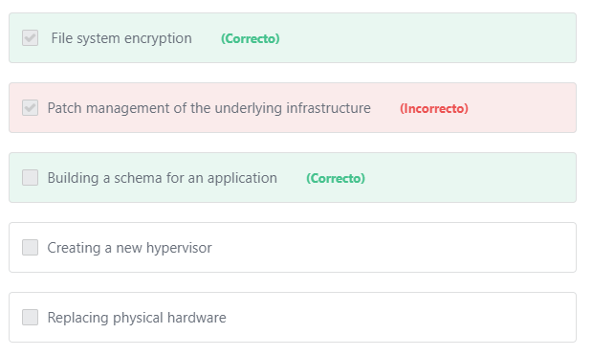

Final del formulario

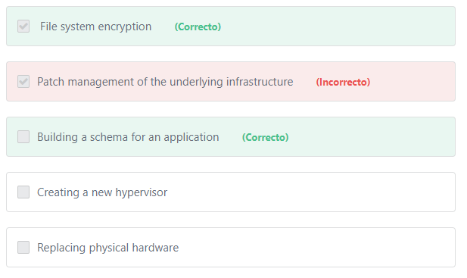Principio del formulario

**Explicación**

          “Security in the Cloud” refers to the Customer’s responsibility in the Shared Responsibility Model. Customers are responsible for items such as building application schema, monitoring server and application performance, configuring security groups and network ACLs, and encrypting their data.

          “Security of the Cloud” refers to the AWS’ responsibility in the Shared Responsibility Model. AWS is responsible for items such as the physical security of the DC (data center), creating hypervisors, replacement of old disk drives, and patch management of the infrastructure.

NOTE:

For "Patch Management",  AWS is responsible for patching the underlying hosts and fixing flaws within the infrastructure, but customers are responsible for patching their guest OS and applications.

**References:**

<https://aws.amazon.com/compliance/shared-responsibility-model/>

Final del formulario

Principio del formulario

Pregunta 18:**Correcto**

**A hospital needs to store medical records for a minimum period of 10 years. The records being stored will only need to be recalled if there is a legal or audit need, which is expected to be extremely infrequent. Which AWS Service offers the most cost-effective method for storing the records?**

Final del formulario

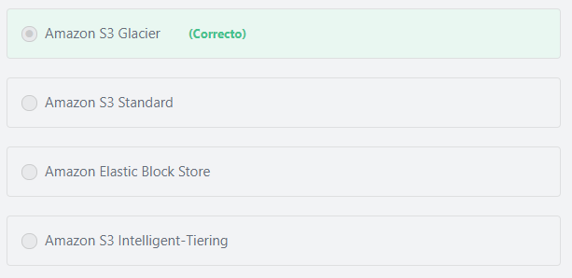

Principio del formulario

**Explicación**

            Amazon S3 Glacier is an extremely low-cost storage service that provides secure, durable, and flexible storage for data backup and archival. With Amazon S3 Glacier, customers can reliably store their data for as little as $0.004 per gigabyte per month. Amazon S3 Glacier enables customers to offload the administrative burdens of operating and scaling storage to AWS, so that they don’t have to worry about capacity planning, hardware provisioning, data replication, hardware failure detection and repair, or time-consuming hardware migrations.

***The other options are incorrect.***

          Amazon S3 Standard, Amazon S3 Intelligent-Tiering, and Amazon Elastic Block Store are all incorrect as each of these options incurs a higher cost per GB than Amazon S3 Glacier, and the question is specifically focused on cost-effectiveness.

**References:**

<https://aws.amazon.com/glacier/>

Final del formulario

Principio del formulario

Pregunta 19:**Incorrecto**

**​ Which AWS Service can perform health checks on Amazon EC2 instances?**

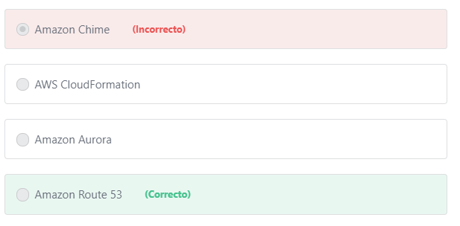

Final del formulario

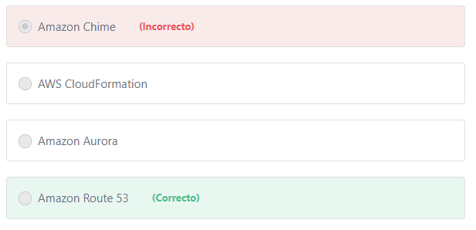Principio del formulario

**Explicación**

             Amazon Route 53 provides highly available and scalable Domain Name System (DNS), domain name registration, and health-checking web services. It is designed to give developers and businesses an extremely reliable and cost effective way to route end users to Internet applications by translating names like example.com into the numeric IP addresses, such as 192.0.2.1, that computers use to connect to each other. Route 53 also offers health checks to monitor the health and performance of your application as well as your web servers and other resources. Route 53 can be configured to route traffic only to the healthy endpoints to achieve greater levels of fault tolerance in your applications.

Note: The Elastic Load Balancing service also performs health checks on Amazon EC2 instances and distribute traffic only to the healthy ones.

***The other options are incorrect:***

***Amazon Aurora is incorrect.*** Amazon Aurora is a relational database service.

***Amazon Chime is incorrect.***Amazon Chime is a communications service for online meetings.

***AWS Cloud​Formation is incorrect.*** AWS CloudFormation allows you to use programming languages or a simple text file (template) to model and provision, in an automated and secure manner, all the resources needed for your applications across all regions and accounts.

**References:**

<https://aws.amazon.com/route53/>

Final del formulario

Principio del formulario

Pregunta 20:**Incorrecto**

**Which of the following approaches will help you eliminate human error and automate the process of creating and updating your  AWS environment?**

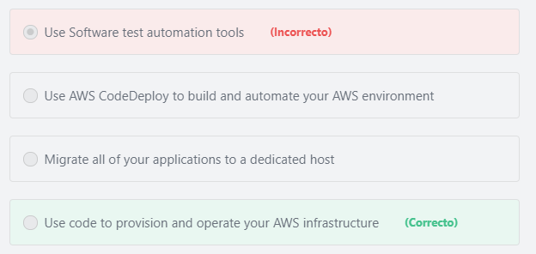

Final del formulario

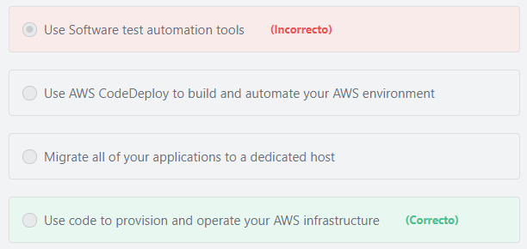Principio del formulario

**Explicación**

             In the cloud, you can apply the same engineering discipline that you use for application code to your entire environment. You can define your entire workload (applications, infrastructure) as code and update it with code. You can implement your operations procedures as code and automate their execution by triggering them in response to events. By performing operations as code, you limit human error and enable consistent responses to events.

            You can define your infrastructure as code using approaches such as AWS CloudFormation templates. The use of templates allows you to build and rebuild your infrastructure, without having to perform manual actions or write custom scripts.

          Codifying your infrastructure in a template allows you to treat your infrastructure as just code. You can author it with any code editor, check it into a version control system, and review the files with team members before deploying into production. This gives developers an easy way to build and update their entire AWS environment in a timely fashion.

***The other options are incorrect.***

***"Use AWS CodeDeploy to build and automate your AWS environment" is incorrect.***AWS CodeDeploy cannot be used to manage the AWS infrastructure. AWS CodeDeploy is a service that automates application code deployments to Amazon EC2 instances and instances running on-premises.

***"Use Software test automation tools" is incorrect.***Software test automation tools enable you to simplify testing and reduce time to release by automating functional tests for your applications.

***"Migrate all of your applications to a dedicated host" is incorrect.***Dedicated Hosts provide you with EC2 instance capacity on physical servers dedicated to your use. You may need to migrate your applications to a dedicated host to use your eligible software licenses from vendors such as Microsoft and Oracle on Amazon EC2 so that you get the flexibility and cost-effectiveness of using your own licenses, but with the resiliency, simplicity, and elasticity of AWS. Amazon EC2 Dedicated Hosts can also help address corporate compliance requirements because they are dedicated only to a single customer.

**References:**

<https://d1.awsstatic.com/whitepapers/architecture/AWS_Well-Architected_Framework.pdf>

<https://aws.amazon.com/cloudformation/>

Final del formulario

Principio del formulario

Pregunta 21:**Incorrecto**

**Which AWS Service allows customers to create a template that programmatically defines policies and configurations of all AWS resources as code and so that the same template can be reused among multiple projects?**

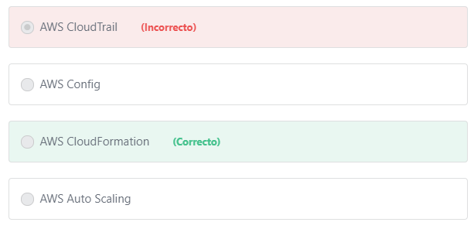

Final del formulario

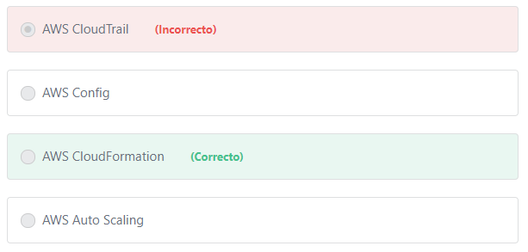Principio del formulario

**Explicación**

           AWS CloudFormation is a service that helps customers model and set up their Amazon Web Services resources so that they can spend less time managing those resources and more time focusing on their applications that run in AWS. Customers create a template that describes all the AWS resources that they want (like Amazon EC2 instances or Amazon RDS DB instances), and AWS CloudFormation takes care of provisioning those resources for them.

           Also, Customers can create an AWS CloudFormation script that captures their security policies, networking policies, and other aspects of configuration and reliably deploys it. Security best practices can then be reused among multiple projects and become part of a continuous integration pipeline.

***The other options are incorrect:***

***AWS Auto Scaling is incorrect.*** AWS Auto Scaling is used to adjust capacity (up or down) automatically to optimize performance and costs.

***AWS CloudTrail is incorrect.*** AWS CloudTrail is a logging service that tracks and records user activity and API usage for audit purposes.

***AWS Config is incorrect.*** AWS Config is used to record and evaluate configurations of your AWS resources.

**References:**

<https://aws.amazon.com/cloudformation/>

Final del formulario

Principio del formulario

Pregunta 22:**Incorrecto**

**A company has a web application that is hosted on a single EC2 instance and is approaching 100 percent CPU Utilization during peak loads. Rather than scaling the server vertically, the company has decided to deploy three Amazon EC2 instances in parallel and to distribute traffic across the three servers. What AWS Service should the company use to distribute the traffic evenly?**

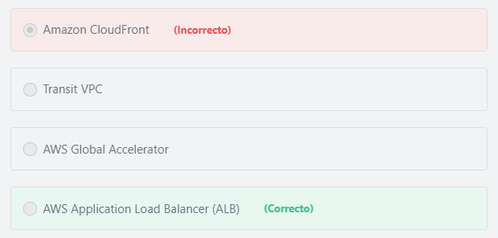

Final del formulario

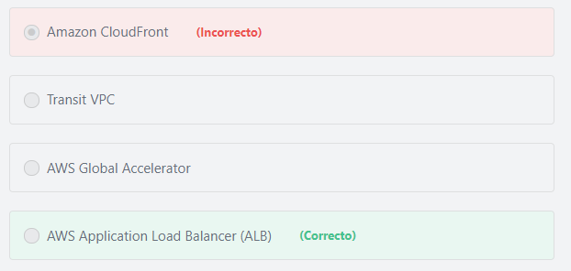Principio del formulario

**Explicación**

            AWS Application Load Balancer (ALB) is part of the AWS Elastic Load Balancing family that is specifically designed to handle HTTP and HTTPS traffic. An ALB automatically distributes incoming application traffic across multiple targets, such as Amazon EC2 instances, containers, and IP addresses. Once you register the Amazon EC2 instances with the ALB, it automatically distributes the incoming traffic across those instances. The Load Balancer also performs health checks on the instances and routes traffic only to the healthy ones.

***The other options are incorrect:***

***"Amazon CloudFront" is incorrect.*** Amazon CloudFront is the AWS’ Content Distribution Network (CDN) and is used to distribute content to global users with low latency.

***"Transit VPC" is incorrect.***A transit Virtual Private Cloud (VPC) is a common strategy for connecting multiple, geographically disperse VPCs and remote networks in order to create a global network transit center. Transit VPCs help organizations transfer data from one Amazon VPC to another, simplifying operations and eliminating the latency issues by peering between resources.

***"AWS Global Accelerator" is incorrect.***AWS Global Accelerator uses the AWS global network to improve the availability and performance of the applications that you offer to your global users. AWS Global Accelerator does not perform load balancing functions.

**References:**

<https://aws.amazon.com/elasticloadbalancing/>

Final del formulario

Principio del formulario

Pregunta 23:**Incorrecto**

**A customer is seeking to store objects in their AWS environment and to make those objects downloadable over the internet. Which AWS Service can be used to accomplish this?**

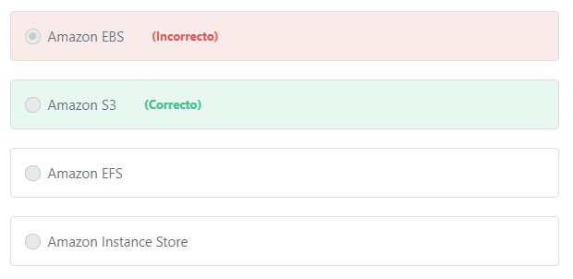

Final del formulario

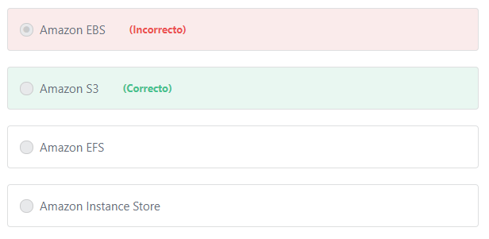Principio del formulario

**Explicación**

          Amazon S3 provides a simple web service interface that you can use to store and retrieve any amount of data, any time, from anywhere on the internet. Amazon S3 assigns a URL for each object you upload. URLs are used to download the objects you want at any time. Amazon S3 is the only AWS service that provides object level storage.

***The other options are incorrect:***

***Amazon EFS is incorrect.***Amazon Elastic File System (AmazonEFS) is not an object store. Amazon EFS is a shared file storage system that scales automatically with use.

***Amazon Elastic Block Store (EBS) is incorrect.*** Amazon Elastic Block Store (Amazon EBS) is not an object store. Amazon EBS is a block storage service that is used to create volumes for use with Amazon EC2 and Amazon RDS.

***Amazon Instance Store is incorrect.***Amazon EC2 Instance Store is not an object store. Amazon EC2 Instance Store provides ephemeral block-level storage that is physically attached to Amazon EC2 instances.

**References:**

<https://aws.amazon.com/s3/faqs/>

Final del formulario

Principio del formulario

Pregunta 24:**Incorrecto**

**Which services does AWS offer for free? (Choose TWO)**

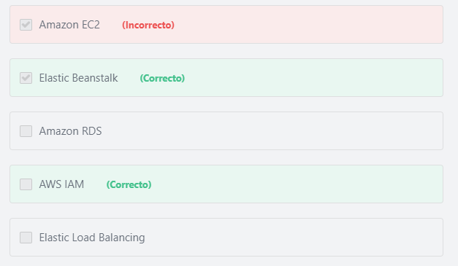

Final del formulario

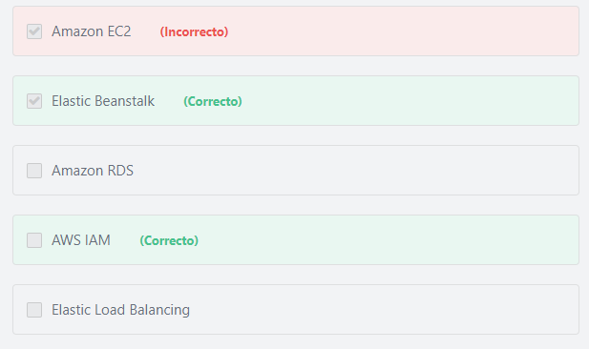Principio del formulario

**Explicación**

           AWS Identity and Access Management is a feature of your AWS account offered at no additional charge. You will be charged only for use of other AWS services by your Users.

           There is no additional charge for AWS Elastic Beanstalk. You pay for AWS resources (e.g. EC2 instances or S3 buckets) you create to store and run your application. You only pay for what you use, as you use it; there are no minimum fees and no upfront commitments.

***The other options are incorrect.***Amazon EC2, Amazon RDS and Elastic Load Balancing are only free for the first 12 months the account exists (during the free tier period), and only within in the service limits described at <https://aws.amazon.com/free/>

**References:**

<https://aws.amazon.com/govcloud-us/pricing/iam/>

<https://aws.amazon.com/elasticbeanstalk/pricing/>

Final del formulario

Principio del formulario

Pregunta 25:**Incorrecto**

**Which IAM entity can best be used to grant temporary access to your AWS resources?**

Final del formulario

#### Explicación

           An IAM role is an IAM entity that defines a set of permissions for making AWS service requests. IAM roles are not associated with a specific user or group. Instead, trusted entities assume roles, such as IAM users, applications, or AWS services such as EC2. An IAM role is similar to an IAM user, in that it is an AWS identity with permission policies that determine what the identity can and cannot do in AWS. However, instead of being uniquely associated with one person, a role is intended to be assumable by anyone who needs it. Also, a role does not have standard long-term credentials such as a password or access keys associated with it. Instead, when you assume a role, it provides you with temporary security credentials for your role session.

          You can use roles to delegate access to users, applications, or services that don't normally have access to your AWS resources. For example, you might want to grant users in your AWS account access to resources they don't usually have, or grant users in one AWS account access to resources in another account. Or you might want to allow a mobile app to use AWS resources, but not want to embed AWS keys within the app. Sometimes you want to give AWS access to users who already have identities defined outside of AWS, such as in your corporate directory. Or, you might want to grant access to your account to third parties so that they can perform an audit on your resources. For these scenarios, you can delegate temporary access to AWS resources using an IAM role.

**The other options are incorrect.**

**"IAM Users" is incorrect.**An IAM user has permanent long-term credentials, not temporary credentials.

**"IAM Groups" is incorrect.**An IAM Group is a way to logically manage sets of IAM Users who require identical permissions.

**"Key Pair" is incorrect.**Amazon EC2 Key Pair enables you to securely access your instances using a private key instead of a password. You can create and download this Key Pair when launching a new EC2 instance.

Additional information:

Key Pair is different than the AWS Access Keys. Access Keys are security credentials (like a user name and password) that allow users to interact with AWS services programmatically.

**References:**

<https://docs.aws.amazon.com/IAM/latest/UserGuide/id_roles.html>

Pregunta 26:**Incorrecto**

**Which AWS Support Plan gives customers access to a “Well-Architected Review” for business critical workloads?**

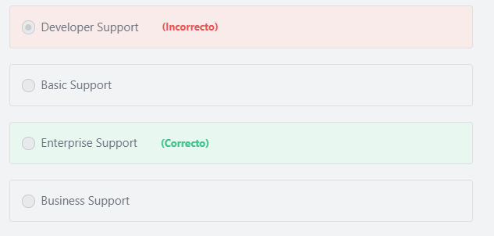

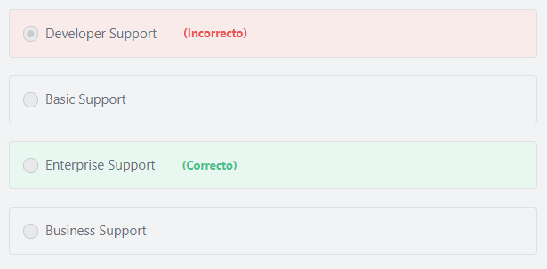Principio del formulario

**Explicación**

The only AWS Support plan that gives customers access to a “Well-Architected Review” delivered by AWS Solution Architects is the Enterprise support plan. This review provides guidance and best practices to help customers design reliable, secure, efficient, and cost-effective systems in the cloud.

**References:**

<https://aws.amazon.com/premiumsupport/compare-plans/>

Final del formulario

Principio del formulario

Pregunta 27:**Correcto**

**A global company with a large number of AWS accounts is seeking a way in which they can centrally manage billing and security policies across all accounts. Which AWS Service will assist them in meeting these goals?**

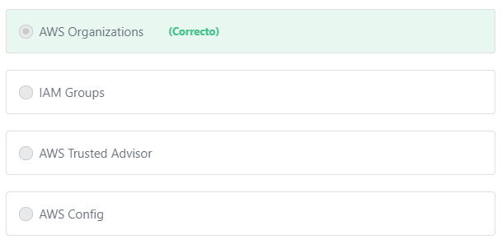

Final del formulario

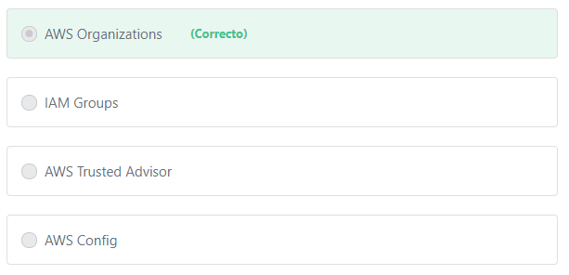Principio del formulario

**Explicación**

          AWS Organizations helps customers centrally govern their environments as they grow and scale their workloads on AWS. Whether customers are a growing startup or a large enterprise, Organizations helps them to centrally manage billing; control access, compliance, and security; and share resources across their AWS accounts.

AWS Organizations has five main benefits:

1) Centrally manage access polices across multiple AWS accounts.

2) Automate AWS account creation and management.

3) Control access to AWS services.

4) Consolidate billing across multiple AWS accounts.

5) Configure AWS services across multiple accounts.

**The other options are incorrect:**

***"AWS Trusted Advisor" is incorrect.***AWS Trusted Advisor is an online tool that provides customers with real time guidance to help them provision their resources following AWS best practices.

***"IAM Groups" is incorrect.***IAM groups are not used to manage multiple AWS accounts. An IAM group is a collection of IAM users - within the same AWS account - that are managed as a unit. IAM Groups let customers specify permissions for multiple users, which can make it easier to manage the permissions for those users. For example, customers could have a group called Admins and give that group the types of permissions that administrators typically need.

***"AWS Config" is incorrect.***AWS Config is a fully managed service that provides customers with an AWS resource inventory, configuration history, and configuration change notifications to enable security and governance.

**References:**

<https://aws.amazon.com/organizations/>

Final del formulario

Principio del formulario

Pregunta 28:**Correcto**

**An AWS customer has used one Amazon Linux instance for 2 hours, 5 minutes and 9 seconds, and one Windows instance for 4 hours, 23 minutes and 7 seconds. How much time will the customer be billed for?**

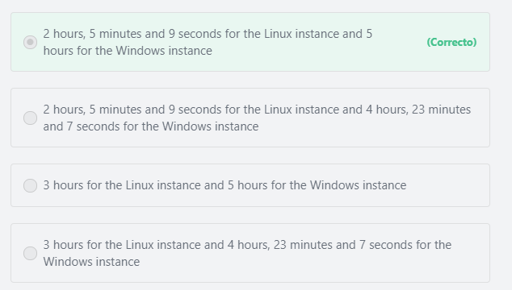

Final del formulario

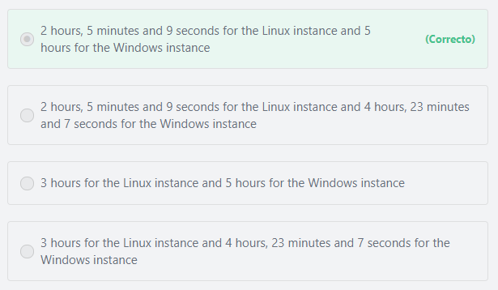Principio del formulario

**Explicación**

         With per-second billing in EC2 you pay for only what you use. It takes cost of unused minutes and seconds in an hour off of the bill, so you can focus on improving your applications instead of maximizing usage to the hour.

Per-second billing is available for instances launched in Amazon Linux or Ubuntu.

For other instances, including Windows, each partial instance-hour consumed will be billed as a full hour.

In this case, the customer will be charged for 2 hours, 5 minutes and 9 seconds for the Linux instance, and 5 hours for the Windows instance.

**References:**

<https://aws.amazon.com/ec2/pricing/>

Final del formulario

Principio del formulario

Pregunta 29:**Correcto**

**​ Which AWS Service provides integration with Chef to automate the configuration of EC2 instances?**

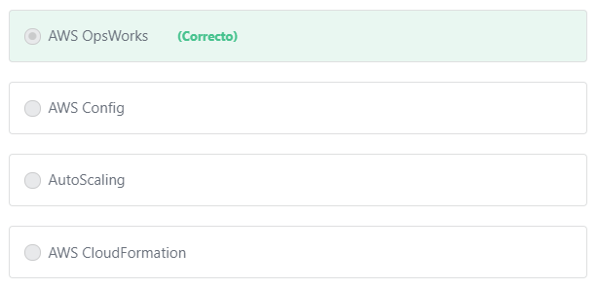

Final del formulario

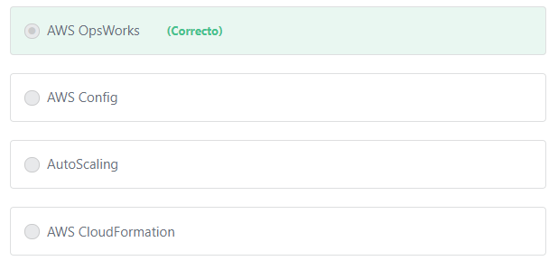Principio del formulario

**Explicación**

            AWS OpsWorks is a configuration management service that provides managed instances of Chef and Puppet. Chef and Puppet are automation platforms that allow you to use code to automate the configurations of your servers. OpsWorks lets you use Chef and Puppet to automate how servers are configured, deployed, and managed across your Amazon EC2 instances or on-premises compute environments.

***The other options are incorrect:***

***AWS CloudFormation is incorrect.***AWS CloudFormation allows customers to provision infrastructure as code.

***AutoScaling is incorrect.***AutoScaling is used to increase or decrease capacity based on demand.

***AWS Config is incorrect.*** AWS Config is a service that enables customers to monitor, assess, and audit all changes made to  AWS resources.

**References:**

<https://aws.amazon.com/opsworks/>

Final del formulario

Principio del formulario

Pregunta 30:**Incorrecto**

**​ Which features are included in the AWS Business Support Plan? (Choose TWO)**

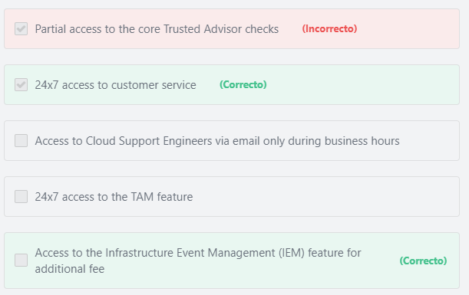

Final del formulario

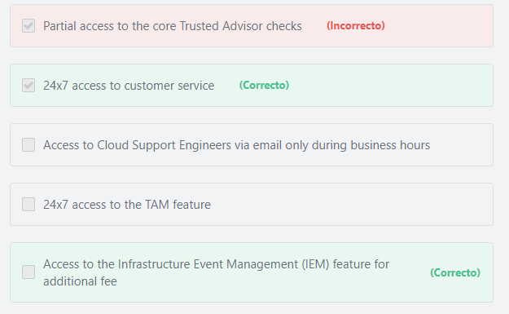Principio del formulario

**Explicación**

          All AWS customers - including Business support plan subscribers - have 24x7 access to customer service. The Business support plan also provides access to Infrastructure Event Management for additional fee. AWS Infrastructure Event Management is a structured program available to Enterprise Support customers (and Business Support customers for an additional fee) that helps customers plan for large-scale events such as product or application launches, infrastructure migrations, and marketing events.

***The other options are incorrect:***

***"24x7 access to the TAM feature" is incorrect.*** The Enterprise support plan is the only plan that provides access to the Technical Account Manager (TAM) feature

***"Access to Cloud Support Engineers via email only during business hours" is incorrect.*** The Business support plan provides 24x7 access to Cloud Support Engineers via phone, email, and chat.

***"Partial access to the core Trusted Advisor checks" is incorrect.***AWS Business Support Plans and Enterprise Support Plans both provide full set of Trusted Advisor checks.

**References:**

<https://aws.amazon.com/premiumsupport/compare-plans/>

Final del formulario

Principio del formulario

Pregunta 31:**Incorrecto**

**Which AWS Service allows customers to download AWS SOC & PCI reports?**

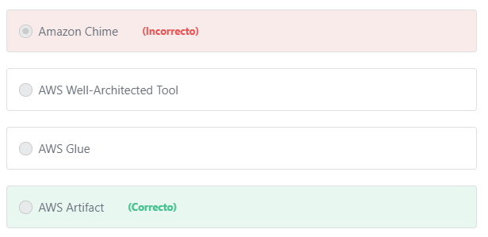

Final del formulario

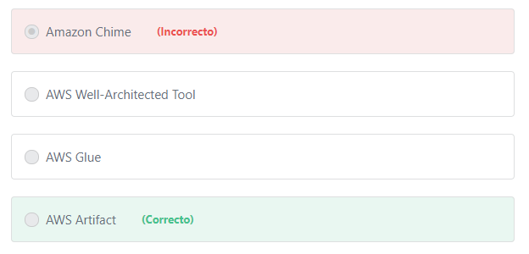Principio del formulario

**Explicación**

                  AWS Artifact provides on-demand downloads of AWS security and compliance documents, such as AWS ISO certifications, Payment Card Industry (PCI), and Service Organization Control (SOC) reports. You can submit the security and compliance documents (also known as audit artifacts) to your auditors or regulators to demonstrate the security and compliance of the AWS infrastructure and services that you use. You can also use these documents as guidelines to evaluate your own cloud architecture and assess the effectiveness of your company's internal controls.

***The other options are incorrect:***

***"Amazon Chime" is incorrect.***Amazon Chime is an AWS communications service that is used for online meetings, video conferencing, calls, and chat.

***"AWS Well-Architected Tool" is incorrect.***The AWS Well-Architected Tool helps customers review the state of their workloads and compares them to the latest AWS architectural best practices. The tool is based on the [AWS Well-Architected Framework](https://aws.amazon.com/architecture/well-architected/), developed to help cloud architects build secure, high-performing, resilient, and efficient application infrastructure.

***"AWS Glue" is incorrect.*** AWS Glue is a fully-managed, pay-as-you-go, extract, transform, and load (ETL) service that automates the time-consuming steps of data preparation for analytics.

**References:**

<https://aws.amazon.com/artifact/>

Final del formulario

Principio del formulario

Pregunta 32:**Incorrecto**

**A company is seeking to deploy an existing .NET application onto AWS as quickly as possible. Which AWS Service should the customer use to achieve this goal?**

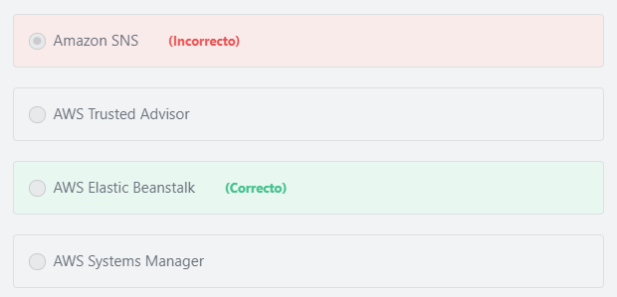

Final del formulario

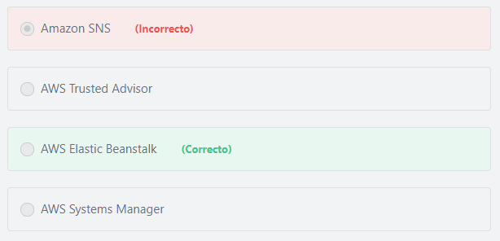Principio del formulario

**Explicación**

            AWS Elastic Beanstalk is an easy-to-use service for deploying and scaling web applications and services developed with Java, .NET, PHP, Node.js, Python, Ruby, Go, and Docker on familiar servers such as Apache, Nginx, Passenger, and IIS. Developers simply upload their application, and Elastic Beanstalk automatically handles the deployment details of capacity provisioning, load balancing, auto-scaling, and application health monitoring.

***The other options are incorrect:***

***"Amazon SNS" is incorrect.***Amazon Simple Notification Service (Amazon SNS) is a messaging service that makes it easy to set up, operate, and send notifications from AWS.

***"AWS Trusted Advisor" is incorrect.***AWS Trusted Advisor analyzes AWS environments and provides best practice recommendations in five categories: cost optimization, security, fault tolerance, performance and service limits.

***"AWS Systems Manager" is incorrect.***AWS Systems Manager allows customers to centralize operational data from multiple AWS services and automate tasks across their AWS resources.

**References:**

<https://aws.amazon.com/elasticbeanstalk/>

Final del formulario

Principio del formulario

Pregunta 33:**Incorrecto**

**How does AWS notify customers about security and privacy events pertaining to AWS services?**

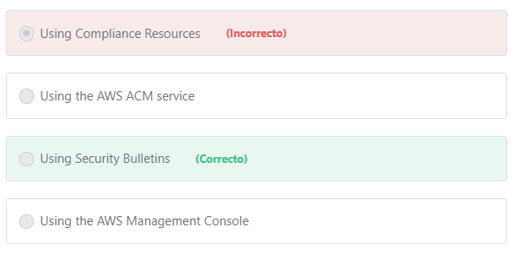

Final del formulario

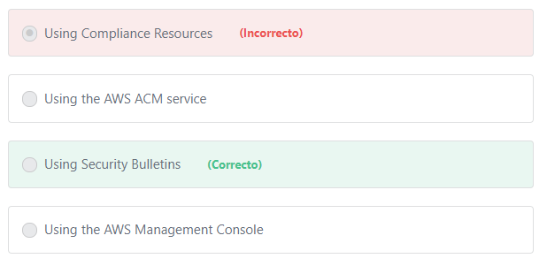Principio del formulario

**Explicación**

             AWS publishes security bulletins about the latest security and privacy events with AWS services on the Security Bulletins page.

***The other options are incorrect:***

***"Using Compliance Resources" is incorrect.***Compliance Resources offers guidance around achieving regulatory compliance on AWS. You can find more information about compliance resources here: <https://aws.amazon.com/compliance/>

***"Using the AWS Management Console" is incorrect.***The AWS Management Console is used to access AWS services, however security and privacy events are available - at the Security Bulletins page - without having to have an AWS account.

***"Using the AWS ACM service" is incorrect.***AWS Certificate Manager (ACM) is a service that lets you easily provision, manage, and deploy public and private Secure Sockets Layer/Transport Layer Security (SSL/TLS) certificates for use with AWS services and your internal connected resources.

**References:**

<https://aws.amazon.com/security/security-bulletins/>

Final del formulario

Principio del formulario

Pregunta 34:**Incorrecto**

**You have just hired a skilled sys-admin to join your team. As usual, you have created a new IAM user for him to interact with AWS services. On his first day, you ask him to create snapshots of all existing Amazon EBS volumes and save them in a new Amazon S3 bucket. However, the new member reports back that he is unable to create neither EBS snapshots nor S3 buckets. What might prevent him from doing this simple task?**

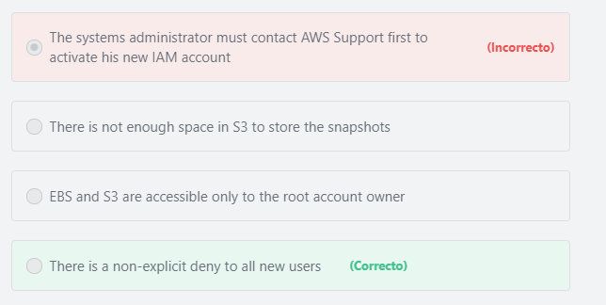

Final del formulario

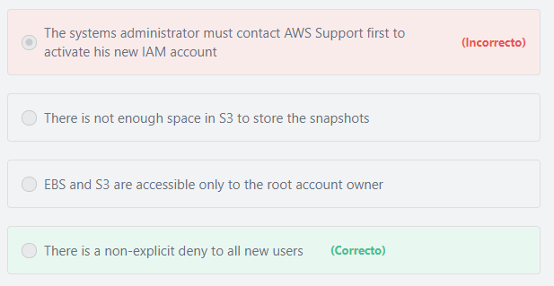Principio del formulario

**Explicación**

         When a new IAM user is created, that user has NO access to any AWS service. This is called a non-explicit deny. For that user, access must be explicitly allowed via IAM permissions.

***The other options are incorrect:***

***“EBS and S3 are accessible only to the root account owner” is incorrect.*** EBS and S3 are accessible to any IAM User, Group, or Role with an attached policy that grants those permissions.

***“The systems administrator must contact AWS Support first to activate his new IAM account” is incorrect.*** Account activation is not required for new IAM users. Account activation is required only for the AWS root account owner, and usually, this process is done automatically without contacting AWS Support.

***“There is not enough space in S3 to store the snapshots” is incorrect.*** Amazon S3 provides virtually unlimited storage capacity.

**References:**

<https://aws.amazon.com/iam/>

Final del formulario

Principio del formulario

Pregunta 35:**Incorrecto**

**​ Which of the following are types of AWS Identity and Access Management (IAM) identities? (Choose TWO)**

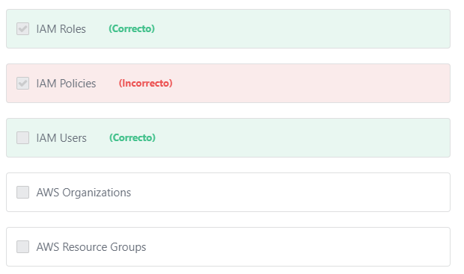

Final del formulario

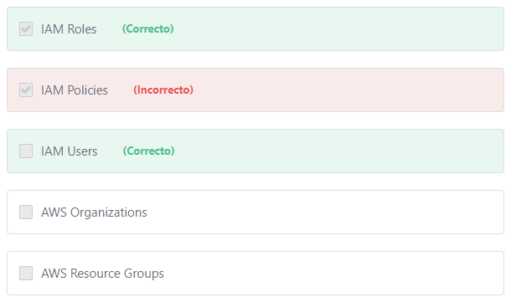Principio del formulario

**Explicación**

               Identities on AWS include users (or groups) and roles. Customers create these identities on AWS to manage access to  AWS resources and determine the actions that each identity can perform on those resources.

**IAM Roles:**

            An IAM role is an IAM identity that you can create in your account that has specific permissions. IAM roles allow you to delegate access (for a limited time) to users, applications or services that normally don't have access to your AWS resources. For example, you might want to grant users in your AWS account access to resources they don't usually have, or grant users in one AWS account access to resources in another account. Or you might want to allow a mobile app to use AWS resources. Sometimes you want to give AWS access to users who already have identities defined outside of AWS, such as in your corporate directory. Or, you might want to grant access to your account to third parties so that they can perform an audit on your resources. For these scenarios, you can delegate access to AWS resources using an IAM role.

**IAM Users:**

          An IAM user is an entity that you create in AWS to represent the person or service that uses it to directly interact with AWS. A primary use for IAM users is to grant individuals access to the AWS Management Console for interactive tasks and / or to make programmatic requests to AWS services using the API or CLI. A user in AWS consists of a name, a password to sign into the AWS Management Console, and up to two access keys that can be used with the API or CLI. When you create an IAM user, you grant it permissions by making it a member of a group that has appropriate permission policies attached (recommended), or by directly attaching policies to the user.

Additional information:

An IAM role is similar to an IAM user, in that it is an AWS identity with permission policies that determine what the identity can and cannot do in AWS. However, instead of being uniquely associated with one person, a role is intended to be assumable by anyone (or any service, application, ...etc) who needs it. Also, a role does not have standard long-term credentials such as a password or access keys associated with it. Instead, when you assume a role, it provides you with temporary security credentials for your role session. IAM roles are meant to be assumed by authorized entities, such as IAM users, applications, or an AWS service such as EC2.

***The other options are incorrect:***

***"AWS Organizations" is incorrect.***AWS Organizations is an account management service that enables you to consolidate multiple AWS accounts into an organization that you create and centrally manage.

***"IAM Policies" is incorrect.***IAM policies let you allow or deny access to AWS services (such as Amazon S3), individual AWS resources (such as a specific S3 bucket), or individual API actions (such as s3:CreateBucket). An IAM policy can be applied only to IAM users, groups, or roles, and it can never restrict the root identity of the AWS account (The AWS root account). It is important to note that while IAM Policies are used by IAM Identities, the policy itself is not a form of IAM Identity.

***"AWS Resource Groups" is incorrect.***Resource Groups are a way to manage multiple resources (such as EC2 instances, S3 buckets, …) as a group rather than move from one AWS service to another for each task.

**References:**

<https://docs.aws.amazon.com/IAM/latest/UserGuide/id.html>

Final del formulario

Principio del formulario

Pregunta 36:**Correcto**

**A company is using EC2 Instances to run their e-commerce site on the AWS platform. If the site becomes unavailable, the company will lose a significant amount of money for each minute the site is unavailable. Which design principle should the company use to minimize the risk of an outage?**

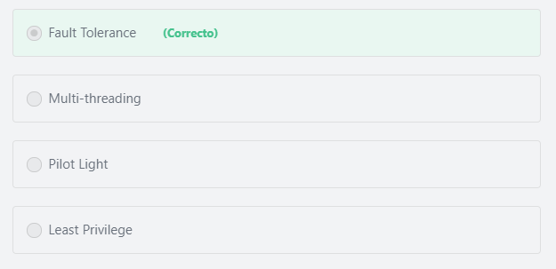

Final del formulario

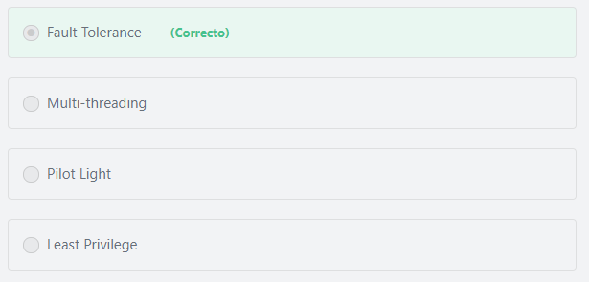Principio del formulario

**Explicación**

          A system that is designed to be fault tolerant can recover gracefully from EC2 instance failures. Amazon Web Services gives customers access to a vast amount of IT infrastructure–compute, storage, and communications–that they can allocate automatically (or nearly automatically) to account for almost any kind of failure.

***The other options are incorrect:***

***“Least Privilege” is incorrect.***Principle of least privilege is a security concept related to access management, not fault tolerance. The principle of least privilege means granting users the required permissions to perform the tasks entrusted to them and nothing more.

***“Pilot Light” is incorrect.***A pilot light scenario is a disaster recover / business continuity scenario wherein a minimal amount of services are kept running in a failover location to enable the business to meet their Recovery Time Objective (RTO) and Recovery Point Objective (RPO) in the event of a disaster. By nature, a pilot light scenario will take some time to spin up and promote to production (as opposed to an active-active DR scenario) and will therefore not mitigate the per-minute losses that will be experienced by the company in the event of an outage.

Additional information: Recovery time objective (RTO) and recovery point objective (RPO) are two key metrics to consider when developing a disaster recover (DR) plan. RTO represents how many hours it takes customers to return to a working state after a disaster. RPO, which is also expressed in hours, represents how much data customers could lose when a disaster happens. For example, an RPO of 1 hour means that customers could lose up to 1 hour’s worth of data when a disaster occurs.

**Read more about disaster recovery scenarios here:**

<https://aws.amazon.com/blogs/publicsector/rapidly-recover-mission-critical-systems-in-a-disaster/>

***“Multi-threading” is incorrect.*** Multi-threading is the ability of a central processing unit (CPU) to provide multiple threads of execution concurrently, which may lead to faster overall execution. Amazon EC2 instances support multi-threading, For example, an m5.xlarge instance type has two CPU cores and two threads per core by default—four threads in total. While multi-threading leads to maximum utilization of the CPU and improves the overall perfomance of EC2 instances, multi-threading has nothing to do with recovering EC2 instances from failures.

**References:**

<https://d1.awsstatic.com/whitepapers/aws-building-fault-tolerant-applications.pdf>

Final del formulario

Principio del formulario

Pregunta 37:**Incorrecto**

**According to best practices, which of the below options is best suited for processing a large number of binary files?**

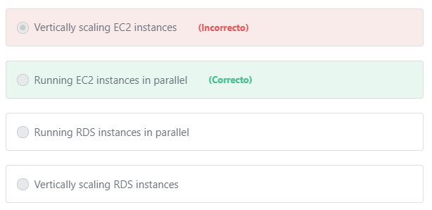

Final del formulario

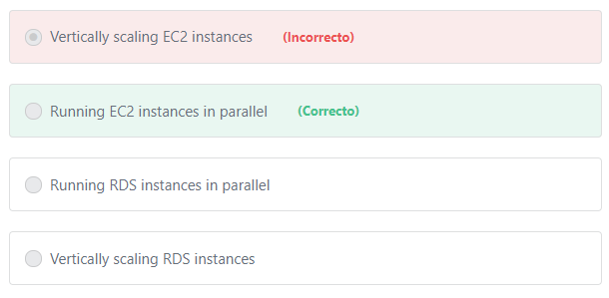Principio del formulario

**Explicación**

        One of the core principles of the AWS Well-Architected Framework is that of scaling horizontally. Horizontal scaling means adding several smaller instances when workloads increase, instead of adding additional CPU, memory, or disk capacity to a single instance. In the syntax of this question, running several EC2 instances in parallel achieves horizontal scalability and is the correct answer.

        AWS recommends that customers should scale resources horizontally to increase aggregate system availability. Replacing a large resource with multiple small resources in parallel will reduce the impact of a single failure on the overall system. For example, if a customer wants to convert a large number of binary files to text files or transcode a large number of video files to another format, it is recommended that they use multiple EC2 instances in parallel instead of using one large instance.

***The other options are incorrect:***

***"Vertically scaling EC2 instances" is incorrect.***Horizontal scaling is recommended over vertical scaling.

***"Vertically scaling RDS instances" and "Running RDS instances in parallel" are incorrect.*** RDS instances are used to store and run databases and would not be used for file processing.

**References:**

<https://aws.amazon.com/blogs/apn/the-5-pillars-of-the-aws-well-architected-framework/>

Final del formulario

Principio del formulario

Pregunta 38:**Incorrecto**

**A company is developing an application that will leverage facial recognition to automate photo tagging. Which AWS Service should the company use for facial recognition?**

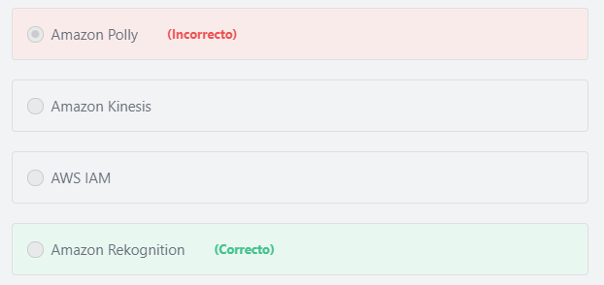

Final del formulario

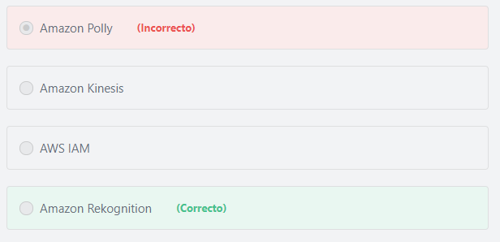Principio del formulario

**Explicación**

           Amazon Rekognition is a service that makes it easy to add image analysis to your applications. With Rekognition, you can detect objects, scenes, and faces in images. You can also search and compare faces. The Amazon Rekognition API enables you to quickly add sophisticated deep-learning-based visual search and image classification to your applications.

***The other options are incorrect:***

***Amazon Kinesis is incorrect.***Amazon Kinesis is used to collect, process, and analyze video and data streams in real time.

***Amazon Polly is incorrect.*** Amazon Polly is a service that turns text into lifelike speech.

***AWS IAM is incorrect.***AWS Identity and Access Management (IAM) enables you to manage access to AWS services and resources securely.

***References:***

<https://d1.awsstatic.com/whitepapers/aws-overview.pdf>    page 46

Final del formulario

Principio del formulario

Pregunta 39:**Incorrecto**

**The TCO gap between AWS infrastructure and traditional infrastructure has widened over the recent years. Which of the following could be the reason for that?**

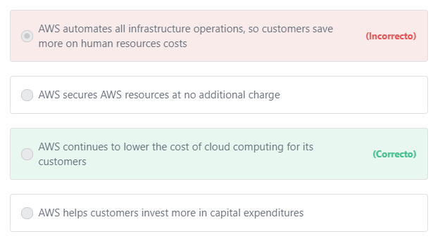

Final del formulario

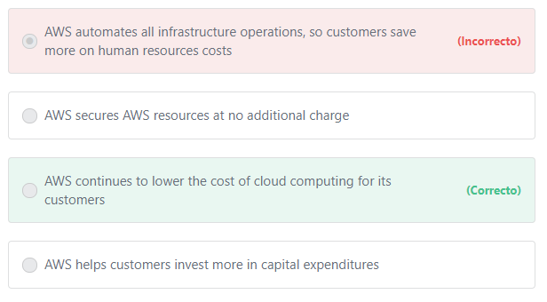Principio del formulario

**Explicación**

           AWS continues to lower the cost of cloud computing for its customers, making everything from web apps to big data on AWS even more cost-effective and widening the TCO (Total Cost of Ownership)  gap with traditional infrastructure. Since 2014, AWS has reduced the cost of compute by an average of 30%, storage by an average of 51% and relational databases by an average of 28%.

***The other options are incorrect:***

***"AWS automates all infrastructure operations, so customers save more on human resources costs" is incorrect.*** AWS does not automate all infrastructure operations. While certain AWS Services, such as RDS, are fully managed services, other aspects of infrastructure management, such as Amazon EC2 remain the responsibility of the customer.

***"AWS helps customers invest more in capital expenditures" is incorrect.*** AWS reduces the need to invest in large capital expenditures and provides a pay-as-you-go model that empowers its customers to invest in the capacity they need and use it only when the business requires it.

***"AWS secures AWS resources at no additional charge" is incorrect.***Securing AWS resources is a shared responsibility between AWS and its customers. Additionally, some AWS security services and features have an associated cost.

**References:**

<https://aws.amazon.com/economics/learn-more/>

Final del formulario

Principio del formulario

Pregunta 40:**Correcto**

**Which of the following are advantages of using AWS as a cloud computing provider? (Choose TWO)**

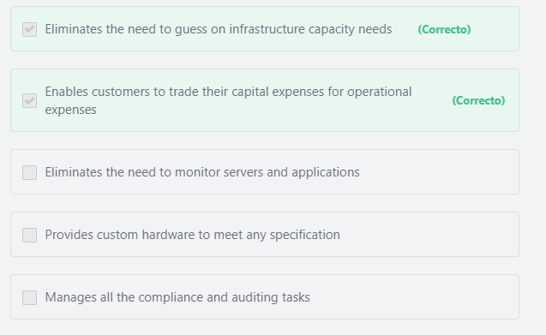

Final del formulario

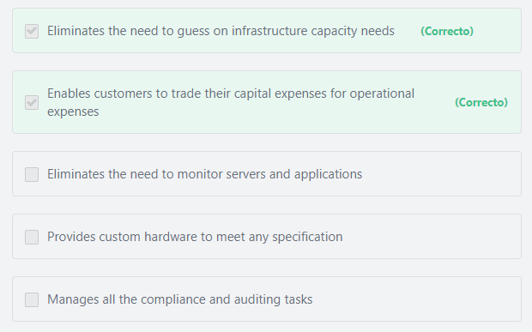Principio del formulario

**Explicación**

**Advantages of Cloud Computing include:  (IMPORTANT)**

**1- Trade capital for variable expense:** Instead of having to invest heavily in data centers and servers before you know how you’re going to use them, you can only pay when you consume computing resources, and only pay for how much you consume. By using AWS, infrastructure costs are converted to a pay-as-you-go model, where customers are charged for the resources that they consume, and those costs are incurred as operating costs instead of as capital expenditures.

**2- Benefit from massive economies of scale:** By using cloud computing, you can achieve a lower variable cost than you can get on your own. Because usage from hundreds of thousands of customers are aggregated in the cloud, providers such as Amazon Web Services can achieve higher economies of scale which translates into lower pay as you go prices.

**3- Stop guessing capacity:** Eliminate guessing on your infrastructure capacity needs. When you make a capacity decision prior to deploying an application, you often either end up sitting on expensive idle resources or dealing with limited capacity. With cloud computing, these problems go away. You can access as much or as little as you need, and scale up and down as required with only a few minutes notice.

**4- Increase speed and agility:** In a cloud computing environment, new IT resources are only ever a click away, which means you reduce the time it takes to make those resources available to your developers from weeks to just minutes. This results in a dramatic increase in agility for the organization, since the cost and time it takes to experiment and develop is significantly lower.

**5- Stop spending money on running and maintaining data centers:** Focus on projects that differentiate your business, not the infrastructure. Cloud computing lets you focus on your own customers, rather than on the heavy lifting of racking, stacking and powering servers.

**6- Go global in minutes:**Easily deploy your application in multiple regions around the world with just a few clicks. This means you can provide a lower latency and better experience for your customers simply and at minimal cost.

***The other options are incorrect:***

***"Eliminates the need to monitor servers and applications" is incorrect.***Using AWS does not eliminate the need to monitor servers and applications. Monitoring servers and applications remains the responsibility of the customer.

***"Manages all the compliance and auditing tasks" is incorrect.***Security and Compliance is a shared responsibility between AWS and the customer. The IT infrastructure that AWS provides to its customers is designed and managed in alignment with best security practices and a variety of IT security standards. Examples of the assurance programs with which AWS complies include SOC, PCI DSS Level 1, ISO 9001, and ISO 27001. AWS customers remain responsible for complying with applicable compliance laws and regulations.

***"Provides custom hardware to meet any specification" is incorrect.***AWS doesn’t provide hardware. AWS provides Cloud Computing services.

**References:**

<https://aws.amazon.com/what-is-cloud-computing/>

Final del formulario

Principio del formulario

Pregunta 41:**Incorrecto**

**Which of the below options is true of Amazon Cloud Directory?**

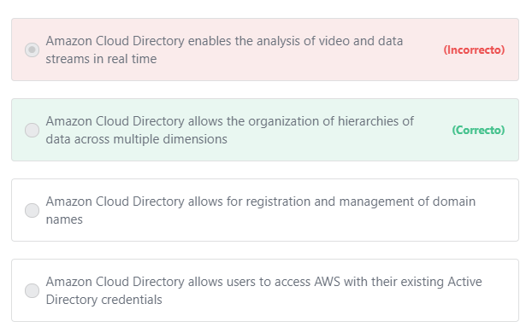

Final del formulario

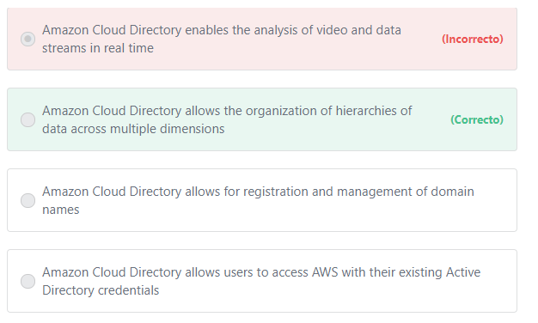Principio del formulario

**Explicación**

          Amazon Cloud Directory is a cloud-native, highly scalable, high-performance directory service that provides web-based directories to make it easy for you to organize and manage all your application resources such as users, groups, locations, devices, and policies, and the rich relationships between them.

          Unlike existing traditional directory systems, Cloud Directory does not limit organizing directory objects in a single fixed hierarchy. In Cloud Directory, you can organize directory objects into multiple hierarchies to support multiple organizational pivots and relationships across directory information. For example, a directory of users may provide a hierarchical view based on reporting structure, location, and project affiliation. Similarly, a directory of devices may have multiple hierarchical views based on its manufacturer, current owner, and physical location. With Cloud Directory, you can create directories for a variety of use cases, such as organizational charts, course catalogs, and device registries.

***The other options are incorrect:***

***"Amazon Cloud Directory allows users to access AWS with their existing Active Directory credentials" is incorrect.***[Amazon Cloud Directory](https://aws.amazon.com/cloud-directory/)***and***[AWS Directory Service](https://aws.amazon.com/directoryservice/) are two different services. AWS Directory Service is the service that provides single sign-on (SSO) to applications and services on AWS. AWS Directory Service uses secure Windows trusts to enable users to sign in to the AWS Management Console and the AWS Command Line Interface (CLI) using their existing corporate Microsoft Active Directory credentials.

***"Amazon Cloud Directory enables the analysis of video and data streams in real time" is incorrect.*** The AWS Service that enables the analysis of video and data streams in real time is Amazon Kinesis.

***"Amazon Cloud Directory allows for registration and management of domain names" is incorrect.*** Amazon Route 53 is the AWS Service that allows for registration and management of domain names.

**References:**

<https://aws.amazon.com/cloud-directory/>

Final del formulario

Principio del formulario

Pregunta 42:**Incorrecto**

**​Your company requires a response time of less than 15 minutes from support interactions about their business-critical systems that are hosted on AWS if those systems go down. Which AWS Support Plan should this company use?**

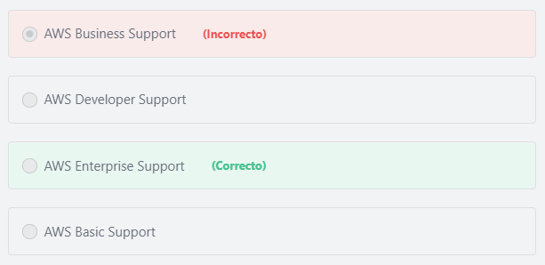

Final del formulario

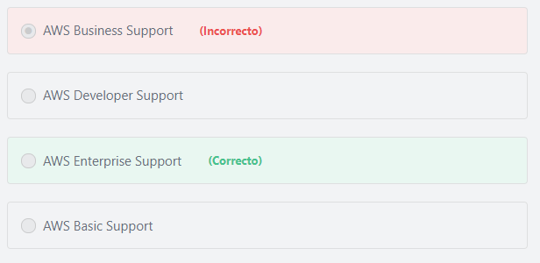Principio del formulario

**Explicación**

          AWS support plans provide different response times based on the case’s severity. For example, the Enterprise plan provides General Guidance within 24 hours. However, if the case involves a business-critical system being down, the company will get a response within 15 minutes.

***The other options are incorrect.***

***Business is incorrect.***The AWS Business Support Plan offers a 1-hour response time for a production system down, which does not meet the 15-minute criteria set forth in the question stem.

***Developer is incorrect.***The AWS Developer Support Plan offers a 12-hour response time for an impaired or down system, which does not meet the 15-minute criteria set forth in the question stem.

***Basic is incorrect.*** Technical Support is not part of the Basic support plan.

**References:**

<https://aws.amazon.com/premiumsupport/compare-plans/>

Final del formulario

Principio del formulario

Pregunta 43:**Correcto**

**Which of the following Amazon RDS features facilitates offloading of database read activity?**

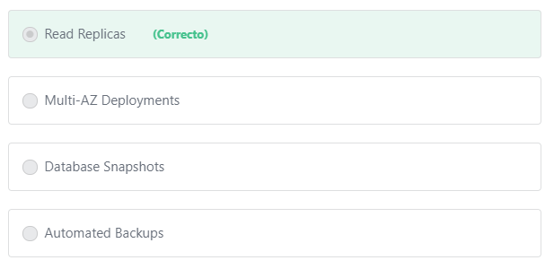

Final del formulario

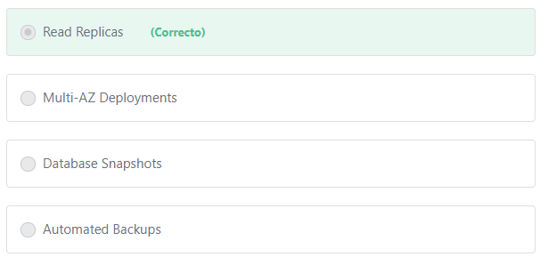Principio del formulario

**Explicación**

             You can reduce the load on your source DB Instance by routing read queries from your applications to one or more read replicas. Read replicas allow you to elastically scale out beyond the capacity constraints of a single DB instance for read-heavy database workloads.

***The other options are incorrect:***

***"Automated Backups" is incorrect.***The automated backup feature of Amazon RDS enables point-in-time recovery for your database instance. This allows you to restore your database instance to any second during the retention period.

Additional information: You can also use the RDS Snapshots feature to manually back up your DB instances.

***"Multi-AZ Deployments" is incorrect.***Multi-AZ Deployments are used to increase the fault tolerance of your application by automatically failing over to the standby DB instance which located in a separate AZ within the same region.

***"Database Snapshots" is incorrect.*** Database snapshots are user-initiated backups of your RDS instance stored in Amazon S3 that are kept until you explicitly delete them.

**References:**

<https://aws.amazon.com/rds/details/read-replicas/>

Final del formulario

Principio del formulario

Pregunta 44:**Incorrecto**

**A key practice when designing solutions on AWS is to minimize dependencies between components so that the failure of a single component does not impact other components. What is this practice called?**

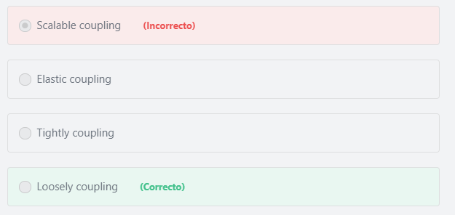

Final del formulario

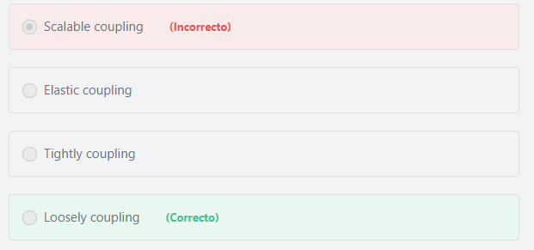Principio del formulario

**Explicación**

           The concept of loosely coupling an application refers to breaking the application into components that perform aspects of a task independently of one another. Using this design concept minimizes the risk that a change or a failure in one component will impact other components.

**References:**

<https://d1.awsstatic.com/whitepapers/architecture/AWS_Well-Architected_Framework.pdf>

Final del formulario

Principio del formulario

Pregunta 45:**Incorrecto**

**An organization has a legacy application designed using monolithic-based architecture. Which AWS Service can be used to decouple the components of the application?**

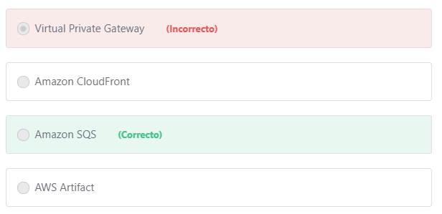

Final del formulario

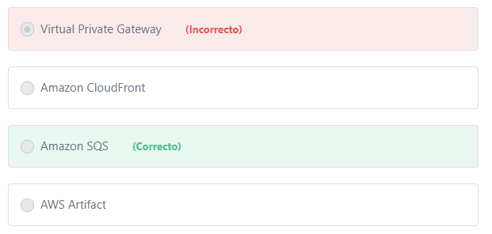Principio del formulario

**Explicación**

         A monolithic application is designed to be self-contained; components of the application are interconnected and interdependent rather than loosely coupled as is the case with Microservices applications.

        With monolithic architectures, all processes are **tightly-coupled** and run as a single service. This means that if one process of the application experiences a spike in demand, the entire architecture must be scaled. Adding or improving a monolithic application’s features becomes more complex as the code base grows. This complexity limits experimentation and makes it difficult to implement new ideas. Monolithic architectures add risk for application availability because many dependent and tightly coupled processes increase the impact of a single process failure.

        With a microservices architecture, an application is built as**loosely-coupled** components that run each application process as a service. These services communicate via a well-defined interface using lightweight APIs. Services are built for business capabilities and each service performs a single function. Because they are independently run, each service can be updated, deployed, and scaled to meet demand for specific functions of an application. Microservices architectures make applications easier to scale and faster to develop, enabling innovation and accelerating time-to-market for new features.

       Amazon Simple Queue Service (SQS) is a fully managed message queuing service that enables you to decouple and scale microservices, distributed systems, and serverless applications. Amazon SQS offers a reliable, highly-scalable hosted queue for storing messages as they travel between applications or microservices. It moves data between distributed application components and helps you decouple these components.

***The other options are incorrect.***

***Virtual Private Gateway is incorrect.***A virtual private gateway (VPG) is the VPN concentrator on the Amazon side of the VPN connection. You create a virtual private gateway and attach it to the VPC from which you want to create the Site-to-Site VPN connection. AWS Virtual Private Network (AWS VPN) is one of the connectivity options that enables you to build hybrid cloud architectures by securely connecting your on-premises network or branch office site to your Amazon Virtual Private Cloud (Amazon VPC).

***Amazon CloudFront is incorrect.***Amazon CloudFront is a global content delivery network (CDN) service.

***AWS Artifact is incorrect.***AWS Artifact is your go-to, central resource for compliance-related information that matters to you. It provides on-demand access to AWS’ security and compliance reports and select online agreements.

**References:**

<https://aws.amazon.com/microservices/>

<https://aws.amazon.com/sqs/>

Final del formulario

Principio del formulario

Pregunta 46:**Incorrecto**

**Which of the following factors should be considered when determining the region in which AWS Resources will be deployed? (Choose TWO)**

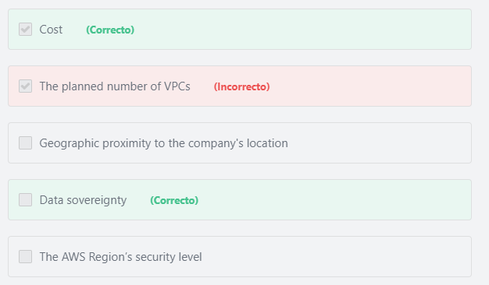

Final del formulario

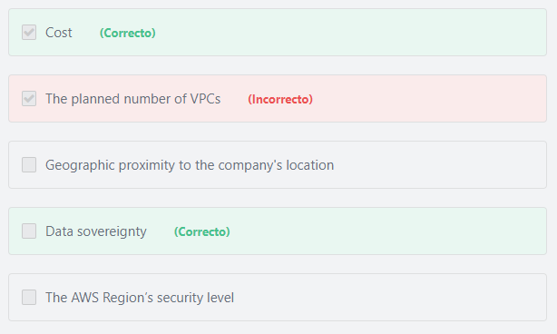Principio del formulario

**Explicación**

          Per AWS Best Practices, proximity to your end users, regulatory compliance, data residency constraints, and cost are all factors you have to consider when choosing the most suitable AWS Region.

***The other options are incorrect:***

***"The planned number of VPCs" is incorrect.*** The number of VPCs a customer can have in a given region is the same irrespective of which AWS Region the customer is using.

***"The AWS Region’s security level" is incorrect.***The level of security is almost identical for all AWS regions.

***"​Geographic proximity to the company's location" is incorrect.*** To achieve the lowest network latency and the quickest response, the best practice is to choose the closest AWS region to the end-users (***not* to** ***the company's location***). For example, if an application is developed in Japan but is primarily accessed by users in North America, the customers will have a better experience (lower application latency) if the application is deployed to AWS Regions in North America than if it were deployed to the Tokyo Region.

**References:**

<https://docs.aws.amazon.com/whitepapers/latest/aws-overview/global-infrastructure.html>

<https://docs.aws.amazon.com/vpc/latest/userguide/amazon-vpc-limits.html>

Final del formulario

Principio del formulario

Pregunta 47:**Incorrecto**

**A company is migrating a web application to AWS. The application’s compute capacity is continually utilized throughout the year. Which of the below options offers the company the most cost-effective solution?**

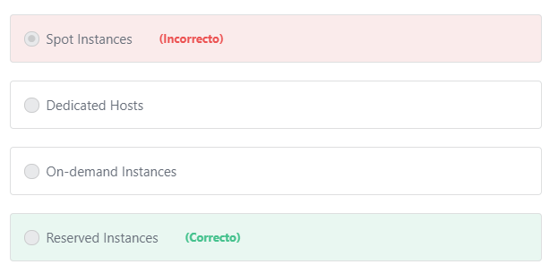

Final del formulario

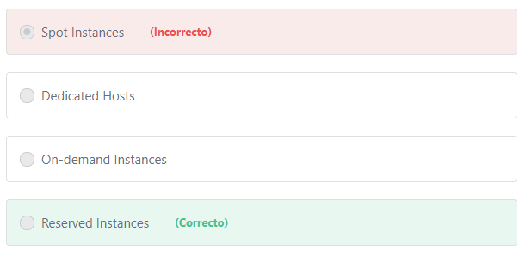Principio del formulario

**Explicación**

            Amazon EC2 Reserved Instances provide a significant discount compared to On-Demand pricing for customers that can commit to using EC2 over a 1- or 3-year term to reduce their total computing costs. Depending on the term of commitment and the amount paid up-front, discounts as high as 75% can be attained vs. On-Demand pricing.

***The other options are incorrect:***

***"On-demand Instances" is incorrect.*** With On-Demand instances, customers pay for the compute capacity by the hour with no long-term commitments. They can increase or decrease the compute capacity depending on the demands of their application and only pay the specified hourly rate for the instances they use. On-demand is recommended for customers who need consistent performance for a short period of time. On-demand instances are significantly less cost-effective than reserved instances.

***"Spot Instances" is incorrect.***Spot instances allow customers to take advantage of excess AWS EC2 capacity by paying a lower hourly price than the On-Demand price. Spot instances are not well suited for production workloads by themselves because the instance can be interrupted at any time if capacity is no longer available. Use cases of Spot instances include batch processing tasks and background jobs.

***"Dedicated Hosts" is incorrect.*** Amazon EC2 Dedicated Hosts are used to help meet corporate compliance requirements and savemoney on licensing costs by enabling customers to use their existing software licenses from vendors such as Microsoft and Oracle on Amazon EC2.

**References:**

<https://aws.amazon.com/ec2/pricing/reserved-instances/>

Final del formulario

Principio del formulario

Pregunta 48:**Incorrecto**

**What should you do if you see resources, which you don’t remember creating, in the AWS Management Console? (Choose TWO)**

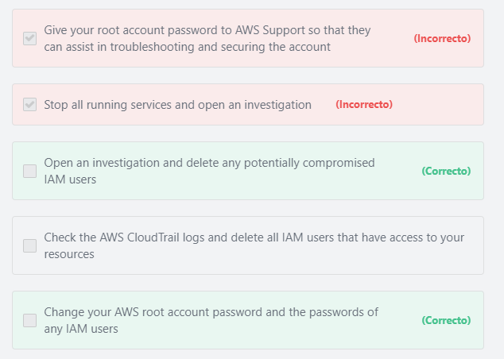

Final del formulario

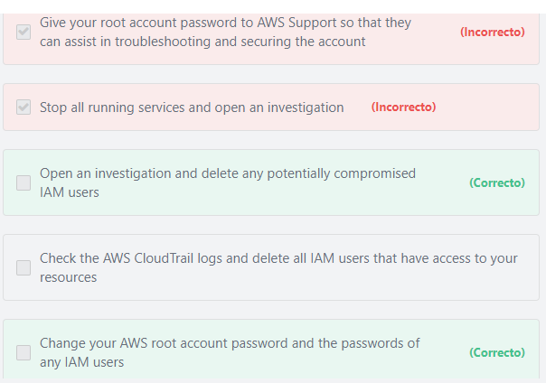Principio del formulario

**Explicación**

          If you suspect that your account has been compromised, or if you have received a notification from AWS that the account has been compromised, perform the following tasks:

1- Change your AWS root account password and the passwords of any IAM users.

2- Delete or rotate all root and AWS Identity and Access Management (IAM) access keys.

3- Delete any potentially compromised IAM users.

4- Delete any resources on your account you didn’t create, such as EC2 instances and AMIs, EBS volumes and snapshots, and IAM users.

5- Respond to any notifications you received from AWS Support through the AWS Support Center.

***The other options are incorrect:***

***"Give your root account password to AWS Support so that they can assist in troubleshooting and securing the account" is incorrect.*** While AWS support can assist in troubleshooting and securing the account, customers should NOT give their root account password to AWS Support (or anyone) for any reason.

***"Check the AWS CloudTrail logs and delete all IAM users that have access to your resources" is incorrect.*** It is a good idea to check the CloudTrail logs that are aggregated recently, however you should not delete all IAM users that have access to your resources. Doing so, will break all the relationships and permissions you have made and may bring down all systems in your account. Instead, you should open an investigation, check the AWS CloudTrail logs, and delete all potentially compromised IAM users.

***"Stop all running services, and open an investigation" is incorrect.***Stopping all running services is not required when investigating such issues.

**References:**

<https://aws.amazon.com/premiumsupport/knowledge-center/potential-account-compromise/>

Final del formulario

Principio del formulario

Pregunta 49:**Incorrecto**

**Which of the following are true regarding the languages that are supported on AWS Lambda? (Choose TWO)**

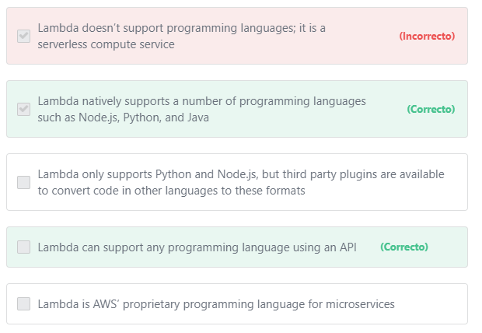

Final del formulario

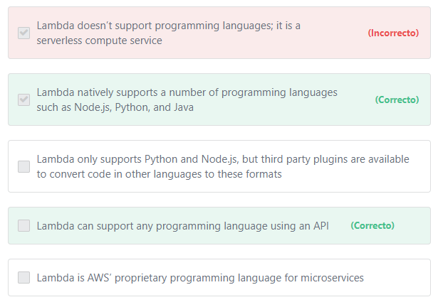Principio del formulario

**Explicación**

            AWS Lambda natively supports Java, Go, PowerShell, Node.js, C#, Python, and Ruby code, and provides a Runtime API which allows customers to use any additional programming languages to author their functions.

***The other options are incorrect:***

***"Lambda only supports Python and Node.js, but third party plugins are available to convert code in other languages to these formats" is incorrect.*** AWS supports many languages natively, including Go, PowerShell, Ruby, and C#. Additionally, there are no third-party plugins that will convert code from one language to another.

***"Lambda doesn’t support programming languages; it is a serverless compute service" is incorrect.*** AWS Lambda is a serverless compute service that lets customers run code written using their preferred programming language.

***"Lambda is AWS’ proprietary programming language for microservices" is incorrect.***Lambda is not a programming language; It allows customers to run code without provisioning or managing servers.

**References:**

<https://aws.amazon.com/lambda/faqs/>

Final del formulario

Principio del formulario

Pregunta 50:**Incorrecto**

**A company is seeking to better secure its AWS account from unauthorized access. Which of the below options can the customer use to achieve this goal?**

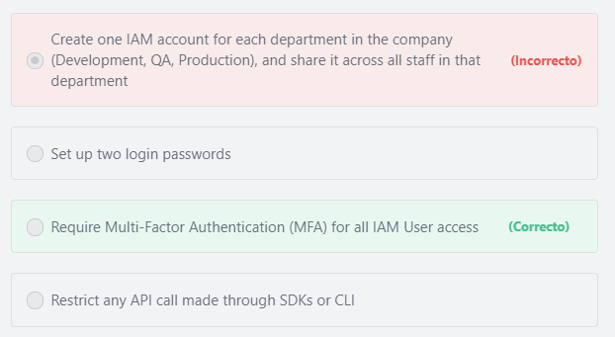

Final del formulario

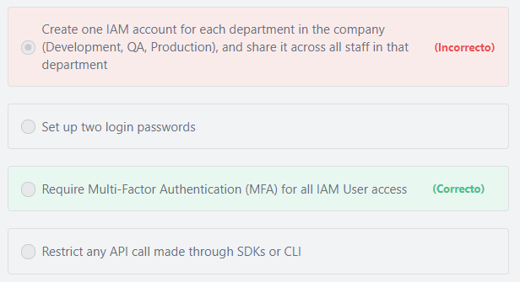Principio del formulario

**Explicación**

          For increased security, AWS recommends that you configure multi-factor authentication (MFA) to help protect your AWS resources. MFA adds extra security because it requires users to provide unique authentication from an AWS supported MFA mechanism in addition to their regular sign-in credentials when they access AWS websites or services. You can also enforce MFA authentication for AWS service APIs via AWS Identity and Access Management (IAM) policies. This provides an extra layer of security over powerful API operations that you designate, such as terminating Amazon EC2 instances or reading sensitive data stored in Amazon S3.

***The other options are incorrect:***

***"Restrict any API call made through SDKs or CLI" is incorrect.***There is nothing wrong with using the AWS SDKs or CLI to interact with AWS services and resources. The API calls made through them can be secured using the AWS Access Keys and the AWS IAM permissions.

***"Set up two login passwords" is incorrect.***AWS doesn’t allow this. Also, it may not improve security because it is the same mechanism.

***"Create one IAM account for each department in the company (Development, QA, Production), and share it across all staff in that department" is incorrect.***It is a best practice for each IAM User to have their own account. Sharing credentials makes it difficult, if not impossible, to audit which user performed specific actions.

**Additional information:**

To make programmatic requests to AWS services using SDKs you must provide valid credentials (Access key ID and secret access key) when setting up your SDK and must also have the IAM permissions that allow you to interact with these services.

AWS CLI is just like the AWS SDKs, you must provide valid credentials (Access key ID and secret access key) when configuring your CLI. To interact with AWS services using the AWS CLI, you must also have the required IAM permissions to use these services.

**References:**

<https://aws.amazon.com/iam/details/mfa/>

Final del formulario

Principio del formulario

Pregunta 51:**Correcto**

**An external auditor is requesting a log of all accesses to the AWS resources in the company’s account. Which of the following services will provide the auditor with the requested information?**

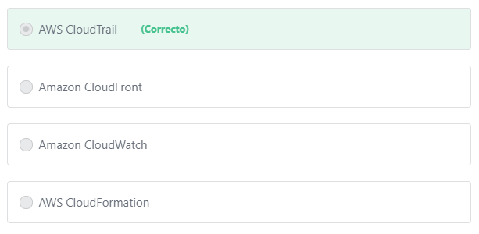

Final del formulario

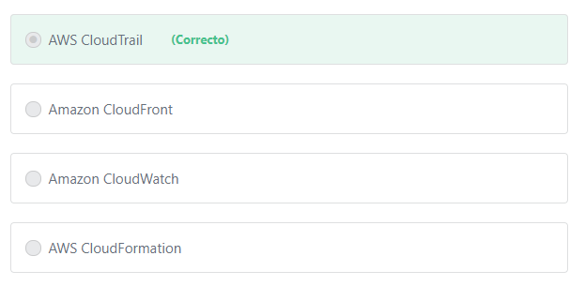Principio del formulario

**Explicación**

             CloudTrail provides visibility into user activity by recording actions taken on your account. CloudTrail records important information about each action, including who made the request, the services used, the actions performed, parameters for the actions, and the response elements returned by the AWS service. This information helps you to enable governance, compliance, operational auditing, and risk auditing of your AWS account.

             CloudTrail provides event history of your AWS account activity, including actions taken through the AWS Management Console, AWS SDKs, command line tools, and other AWS services. This event history simplifies security analysis, resource change tracking, and troubleshooting.

***The other options are incorrect:***

***Amazon CloudFront is incorrect.*** Amazon CloudFront is a fast content delivery network (CDN) service that securely delivers data, videos, applications, and APIs to customers globally with low latency and high transfer speeds.

***Amazon CloudWatch is incorrect.*** Amazon CloudWatch is used to monitor the utilization of the AWS cloud resources (such as Amazon EC2 instances, Amazon DynamoDB tables, and Amazon RDS DB instances) , as well as custom metrics generated by your applications and services.

***AWS CloudFormation is incorrect.***AWS CloudFormation allows you to model your entire infrastructure with either a text file or programming languages, also referred to as infrastructure as code.

**References:**

<https://aws.amazon.com/cloudtrail/>

Final del formulario

Principio del formulario

Pregunta 52:**Incorrecto**

**Which of the below options are use cases of the Amazon Route 53 service? (Choose TWO)**

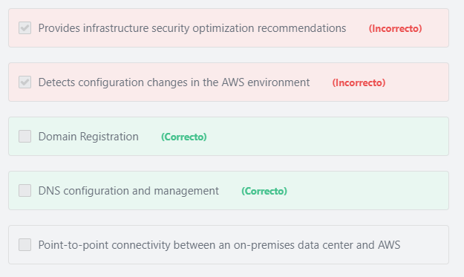

Final del formulario

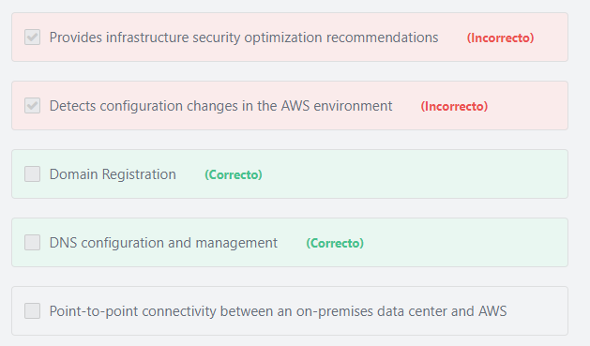Principio del formulario

**Explicación**

               Amazon Route 53 is AWS's domain and DNS management service. You can use it to register new domain names, as well as manage your Domain Name System (DNS) in the Cloud.

               Amazon Route 53 also simplifies the hybrid cloud by providing recursive DNS for your Amazon VPC and on-premises networks over AWS Direct Connect or AWS VPN.

***The other options are incorrect:***

***"Provides infrastructure security optimization recommendations" is incorrect.*** Route 53 does not provide infrastructure security optimization recommendations. The name of the service that performs this function is AWS Trusted Advisor.

***"Detects configuration changes in the AWS environment" is incorrect.*** Route 53 is not used to detect configuration changes in the AWS environment. The name of the service that performs this function is AWS Config.

***"***​***Point-to-point connectivity between an on-premises data center and AWS" is incorrect.***Route 53 does not provide point-to-point connectivity between an on-premises data center and AWS. The name of the service that performs this function is AWS Direct Connect.

**References:**

<https://aws.amazon.com/route53/>

Final del formulario

Principio del formulario

Pregunta 53:**Incorrecto**

**A company is building an online cloud storage platform. They need a storage service that can scale capacity automatically, while minimizing cost. Which AWS storage service should the company use to meet these requirements?**

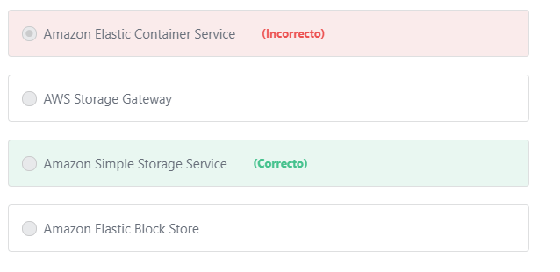

Final del formulario

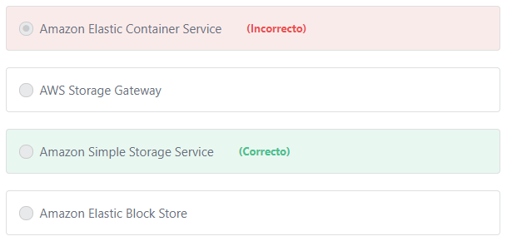Principio del formulario

**Explicación**

         Amazon S3 is a storage service offered by AWS that offers highly redundant object storage to AWS customers. Amazon S3 allows customers to effectively store and retrieve any amount of data from anywhere. Amazon S3 offers an extremely durable, highly available, and infinitely scalable data storage infrastructure at very low costs.

***The other options are incorrect:***

***Amazon Elastic Container Service is incorrect.***Amazon Elastic Container Service (Amazon ECS) is a container orchestration service that is used to run containerized applications on AWS.

***Amazon Elastic Block Store is incorrect.***AmazonElastic Block Store is a block storage offering inside of AWS. While EBS can be configured to be highly performant, it is significantly more expensive than S3, and requires configuration modifications to grow the device capacity.

         Amazon EBS can only be used as a drive for Amazon EC2 or Amazon RDS instances. Amazon EBS is designed for application workloads that benefit from fine tuning for performance and capacity. Typical use cases include Big Data analytics engines (like the Hadoop/HDFS ecosystem and Amazon EMR clusters), relational and NoSQL databases (like Microsoft SQL Server and MySQL or Cassandra and MongoDB), stream and log processing applications (like Kafka and Splunk), and data warehousing applications (like Vertica and Teradata).

***AWS Storage Gateway is incorrect.***AWS Storage Gateway is a hybrid storage service that enables your on-premises applications to seamlessly interact with AWS cloud storage. You can use the service for backup and archiving, disaster recovery, cloud data processing, storage tiering, and migration.

**References:**

<https://aws.amazon.com/s3/>

Final del formulario

Principio del formulario

Pregunta 54:**Incorrecto**

**There is a requirement to grant a DevOps team full administrative access to all resources in an AWS account. Who can grant them these permissions?**

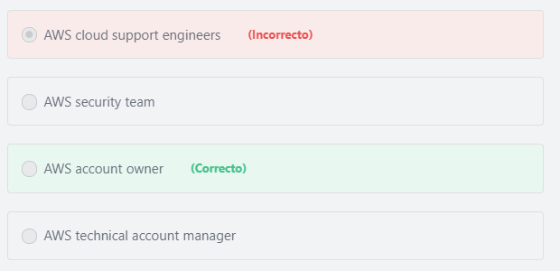

Final del formulario

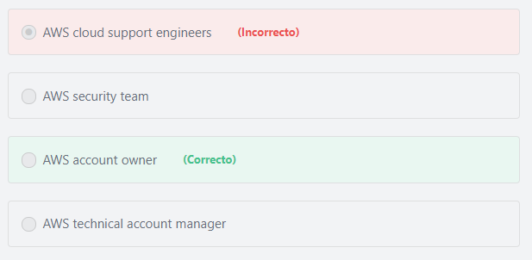Principio del formulario

**Explicación**

The account owner is the entity that has complete control over all resources in his AWS account.

***The other options are incorrect.***

***"AWS cloud support engineers" is incorrect.***AWS cloud support engineers provide technical support to customers who are having issues with the system. Cloud support engineers are available only for the Business and Enterprise support plans.

***"AWS technical account manager" is incorrect.***AWS technical account manager (TAM) helps AWS customers craft and execute strategies to drive their adoption and use of AWS services. AWS TAM is available only for the Enterprise support plan.

***AWS security team is incorrect.***The AWS Security Team is an internal AWS team that is responsible for the security of services offered by AWS.

**References:**

<https://docs.aws.amazon.com/general/latest/gr/root-vs-iam.html>

Final del formulario

Principio del formulario

Pregunta 55:**Incorrecto**

**What are the advantages of using Auto Scaling Groups for EC2 instances?**

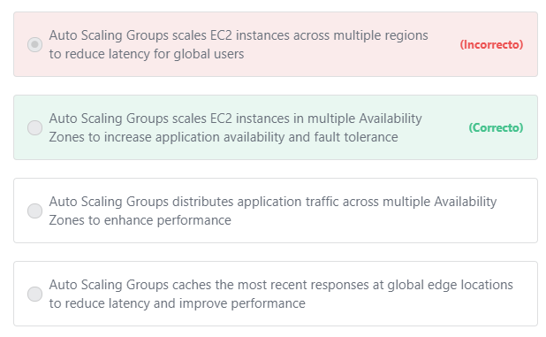

Final del formulario

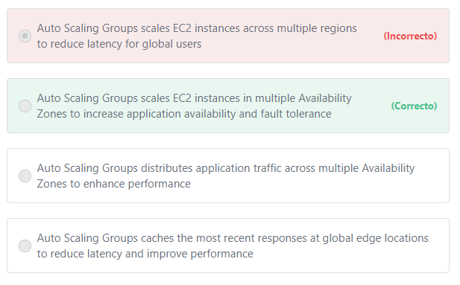Principio del formulario

**Explicación**

Amazon EC2 Auto Scaling offers the following benefits:

1- Better fault tolerance. Amazon EC2 Auto Scaling can detect when an instance is unhealthy, terminate it, and launch an instance to replace it. Also, Amazon EC2 Auto Scaling enables you to take advantage of the safety and reliability of geographic redundancy by spanning Auto Scaling groups across multiple Availability Zones within a Region. When one Availability Zone becomes unhealthy or unavailable, Auto Scaling launches new instances in an unaffected Availability Zone. When the unhealthy Availability Zone returns to a healthy state, Auto Scaling automatically redistributes the application instances evenly across all of the designated Availability Zones.

2- Better availability. Amazon EC2 Auto Scaling helps ensure that your application always has the right amount of capacity to handle the current traffic demand.

3- Better cost management. Amazon EC2 Auto Scaling can dynamically increase and decrease capacity as needed. Because you pay for the EC2 instances you use, you save money by launching instances when they are needed and terminating them when they aren't.

***The other options are incorrect:***

***"Auto Scaling Groups distributes application traffic across multiple Availability Zones to enhance performance" is incorrect.***AWS ELB is the service that is used to distribute traffic. Auto Scaling Groups do not distribute traffic

***"Auto Scaling Groups scales EC2 instances across multiple regions to reduce latency for global users" is incorrect.*** An Auto Scaling group can contain EC2 instances in one or more Availability Zones within the same Region. However, Auto Scaling groups cannot span multiple Regions.

***"Auto Scaling Groups caches the most recent responses at global edge locations to reduce latency and improve performance" is incorrect.***Amazon CloudFront is the service that is used to cache the most recent responses at global edge locations to provide faster performance for global users. Auto Scaling Groups do not perform any caching.

**References:**

<https://docs.aws.amazon.com/autoscaling/ec2/userguide/what-is-amazon-ec2-auto-scaling.html>

Final del formulario

Principio del formulario

Pregunta 56:**Incorrecto**

**Which AWS Service offers volume discounts based on usage?**

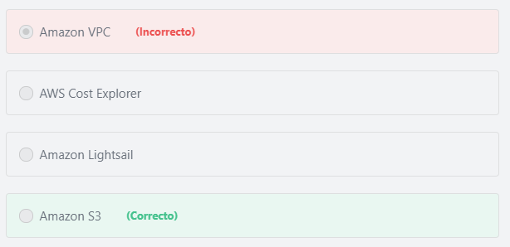

Final del formulario

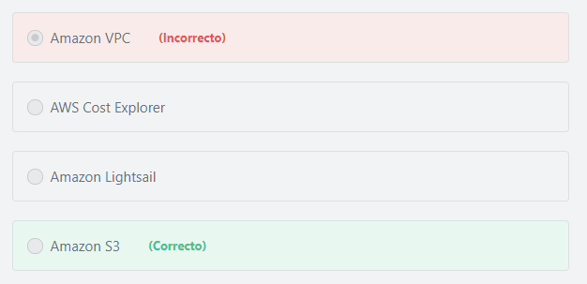Principio del formulario

**Explicación**

            Some AWS services are priced in *tiers*, which specify unit costs for defined amounts of AWS usage. As your usage increases, your usage crosses thresholds into new pricing tiers that specify lower unit costs for additional usage in a month. For example, the more Amazon S3 capacity a customer uses, the lower the cost per unit volume.

The current S3 pricing for the us-east-1 region is:

1st tier: $0.023 per GB / month for the first 50 TB stored

2nd tier: $0.022 per GB / month for the next 450 TB stored

3rd tier: $0.021 per GB / month for all storage consumed above 500 TB.

Additional information:

Using [consolidated billing](https://docs.aws.amazon.com/awsaccountbilling/latest/aboutv2/consolidated-billing.html), customers can combine usage from multiple AWS accounts into a single invoice, allowing them to reach the tiers with lower prices faster.

**References:**

<https://aws.amazon.com/s3/pricing/>

Final del formulario

Principio del formulario

Pregunta 57:**Incorrecto**

**Which of the below options is a best practice for making your application on AWS highly available?**

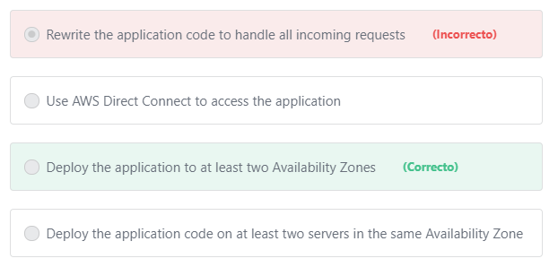

Final del formulario

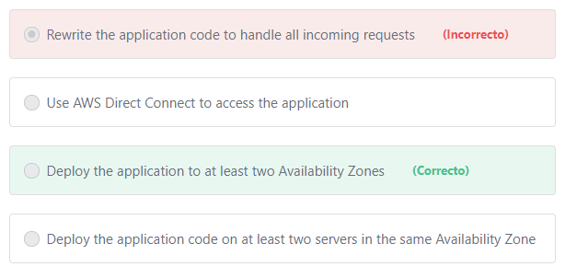Principio del formulario

**Explicación**

             Each AWS Region contains multiple distinct locations, or Availability Zones. Each Availability Zone is engineered to be independent from failures in other Availability Zones. Deploying your application to multiple Availability Zones will increase the availability of your application. If one availability zone encounters an issue, the other availability zones can still serve your application.

***The other options are incorrect:***

***"Use AWS Direct Connect to access the application" is incorrect.*** AWS Direct Connect is an AWS offering that facilitates the establishment of a dedicated network connection from your premises to AWS.

***"Deploy the application code on at least two servers in the same Availability Zone" is incorrect.***Using more AWS servers in the same Availability Zone would help with performance so long as the Availability Zone had no issues, but being deployed to only one Availability Zone constitutes a single point of failure and is therefore not a best practice.

***"Rewrite the application code to handle all incoming requests" is incorrect.*** There is no relation between the application code and “high availability”. Even perfectly written code that never crashes will become unavailable if the infrastructure it runs on fails.

**References:**

<https://aws.amazon.com/about-aws/global-infrastructure/regions_az/>

Final del formulario

Principio del formulario

Pregunta 58:**Incorrecto**

**​One of the major advantages of using AWS is cost savings. Which of the below options is an example of the cost savings offered by AWS?**

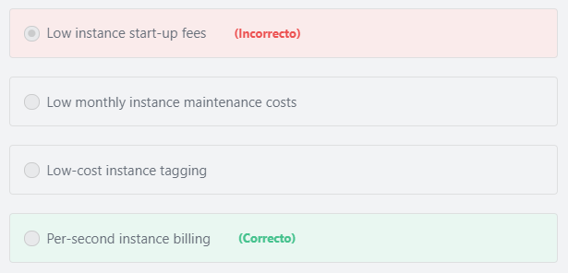

Final del formulario

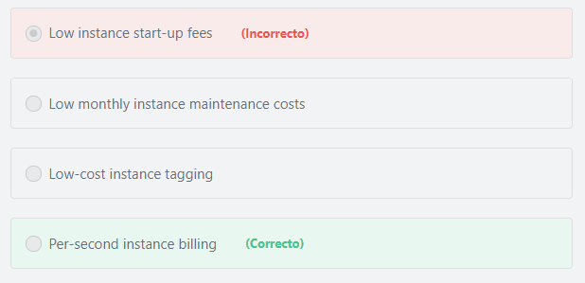Principio del formulario

**Explicación**

          With per-second billing, customers pay for only what they use. It takes the cost of unused minutes and seconds in an hour off of the bill, so they can focus on improving their applications instead of maximizing usage to the hour. Especially, if a customer manages instances running for irregular periods of time, such as dev/testing, data processing, analytics, batch processing, and gaming applications, can benefit.

          EC2 usage is billed on one-second increments, with a minimum of 60 seconds. Similarly, provisioned storage for EBS volumes will be billed per-second increments, with a 60 second minimum. Per-second billing also applies to several other AWS services, including Amazon RDS, Amazon EMR, and AWS Batch.

***The other options are incorrect:***

***"***​***Low-cost instance tagging" is incorrect.*** There is no charge for tagging EC2 instances; it is a free feature.

***"Low instance start-up fees" is incorrect.***There are no instance start-up fees when using EC2.

***"Low monthly instance maintenance costs" is incorrect.***There are no additional maintenance costs for running an EC2 instance; the only cost for running an EC2 instance is the associated hourly cost.

**References:**

<https://aws.amazon.com/ec2/pricing/>

Final del formulario

Principio del formulario

Pregunta 59:**Incorrecto**

**Which AWS Group assists customers in achieving their desired business outcomes?**

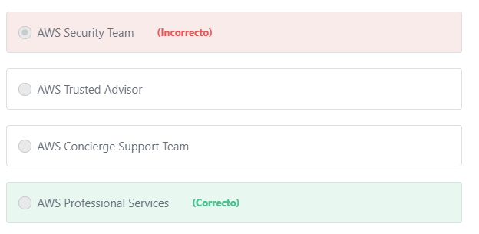

Final del formulario

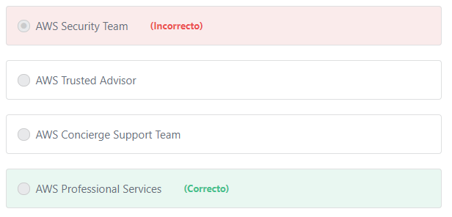Principio del formulario

**Explicación**

           Moving to AWS provides customers with sustainable business advantages. Choosing to supplement teams with specialized skills and experience can help customers achieve those results. The AWS Professional Services organization is a global team of experts that helps customers realize their desired business outcomes when using AWS.

***The other options are incorrect:***

***AWS Concierge Support Team*** ***is incorrect.*** The Concierge Team are AWS billing and account experts that work with you to implement billing and account best practices.

***AWS Trusted Advisor is incorrect.*** AWS Trusted Advisor is not a team, it is an online tool that offers a rich set of best practice checks and recommendations across five categories: cost optimization, security, fault tolerance, performance, and service limits.

***AWS Security Team is incorrect.***The AWS Security Team is responsible for the security of services offered by AWS.

**References:**

<https://aws.amazon.com/professional-services/>

Final del formulario

Principio del formulario

Pregunta 60:**Incorrecto**

**What does AWS offer to protect your data? (Choose TWO)**

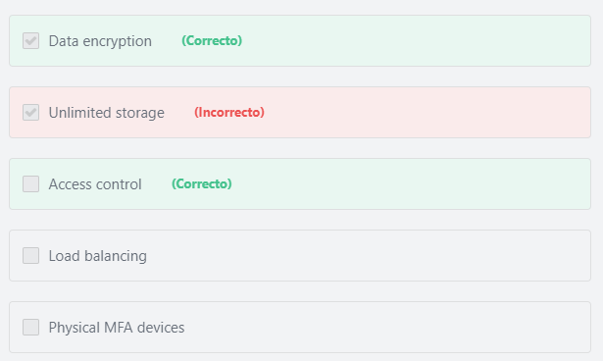

Final del formulario

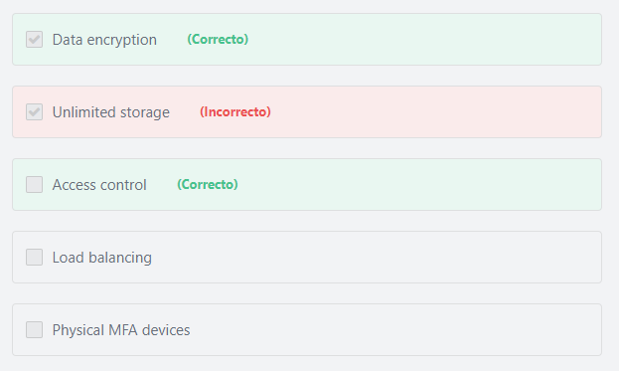Principio del formulario

**Explicación**

             AWS offers a lot of services and features that help you in protecting your data in the cloud. You can protect your data by encrypting it in transit and at rest. You can use Cloudtrail to log API and user activity, including who, what, and from where calls were made. You can also use the AWS Identity and Access Management (IAM) to control who can access or edit your data. You can also use advanced managed security services such as Amazon Macie, which assists in discovering and securing personal data that is stored in Amazon S3.

**In brief, the customer is responsible for protecting their data in the following ways:**

1- Data encryption (at rest and in transit)

2- Setting up access control

3- Monitoring user activity

4- Applying MFA

5- Using advanced managed security services such as Amazon Macie.

**Additional information:**

Amazon Macie uses machine learning to automatically discover, classify, and protect sensitive data in AWS. Amazon Macie recognizes sensitive data such as personally identifiable information (PII) or intellectual property, and provides you with dashboards and alerts that give visibility into how this data is being accessed or moved. The fully managed service continuously monitors data access activity for anomalies, and generates detailed alerts when it detects risk of unauthorized access or inadvertent data leaks. Today, Amazon Macie is available to protect data stored in Amazon S3, with support for additional AWS data stores coming later this year.

***The other options are incorrect:***

***"Load balancing" is incorrect.*** There is no relation between Load Balancing and data protection. Load Balancing is the process of distributing incoming application traffic across multiple targets, such as Amazon EC2 instances, containers, IP addresses, and Lambda functions. Elastic Load Balancing offers three types of load balancers that all feature the high availability, automatic scaling, and robust security necessary to make your applications fault-tolerant. You can select the appropriate load balancer based on your application needs. If you need to load balance HTTP requests, AWS recommends you to use Application Load Balancer. For network/transport protocols (layer4 – TCP, UDP) load balancing, and for extreme performance/low latency applications, AWS recommends using Network Load Balancer. If your application is built within the EC2 Classic network, then you should use Classic Load Balancer.

***"Physical MFA devices" is incorrect.***MFA can help protect your data, but AWS doesn’t provide physical MFA devices, you may purchase them from a third-party provider or use a virtual MFA device such as your smartphone.

***"Unlimited storage" is incorrect.***AWS offers unlimited storage for its customers, but this has nothing to do with data protection.

**References:**

<https://docs.aws.amazon.com/awscloudtrail/latest/userguide/data-protection.html>

<https://aws.amazon.com/iam/features/mfa/>

<https://aws.amazon.com/security/>

Final del formulario

Principio del formulario

Pregunta 61:**Incorrecto**

**A company is developing a mobile application and wants to allow users to use their Amazon, Apple, Facebook, or Google identities to authenticate to the application. Which AWS Service should the company use for this purpose?**

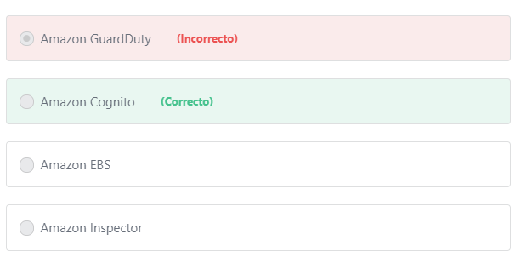

Final del formulario

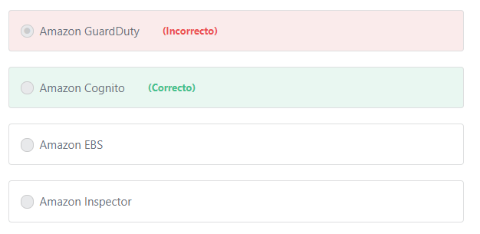Principio del formulario

**Explicación**

             Amazon Cognito lets customers add user sign-up, sign-in, and access control to their web and mobile apps quickly and easily. Amazon Cognito scales to millions of users and supports sign-in with social identity providers, such as Facebook, Google, and Amazon, and enterprise identity providers via SAML 2.0.

***The other options are incorrect:***

***Amazon GuardDuty is incorrect.*** Amazon GuardDuty is a threat detection service that continuously monitors for malicious activity and unauthorized behavior to protect your AWS accounts and workloads. With the cloud, the collection and aggregation of account and network activities is simplified, but it can be time consuming for security teams to continuously analyze event log data for potential threats. GuardDuty analyzes tens of billions of events across multiple AWS data sources, such as AWS CloudTrail, Amazon VPC Flow Logs, and DNS logs. With GuardDuty, you now have an intelligent and cost-effective option for continuous threat detection in the AWS Cloud. The service uses machine learning, anomaly detection, and integrated threat intelligence to identify and prioritize potential threats. Amazon GuardDuty is not an application authentication service.

***Amazon Inspector is incorrect.***Amazon Inspector is an automated security assessment service that helps improve the security and compliance of applications deployed on AWS.

***Amazon EBS is incorrect.***Amazon Elastic Block Store (Amazon EBS) provides persistent block level storage volumes for use with Amazon EC2 instances.

**References:**

<https://aws.amazon.com/cognito/>

Final del formulario

Principio del formulario

Pregunta 62:**Incorrecto**

**Which methods can be used by customers to interact with AWS Identity and Access Management (IAM)? (Choose TWO)**

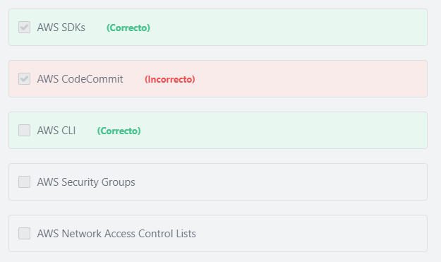

Final del formulario

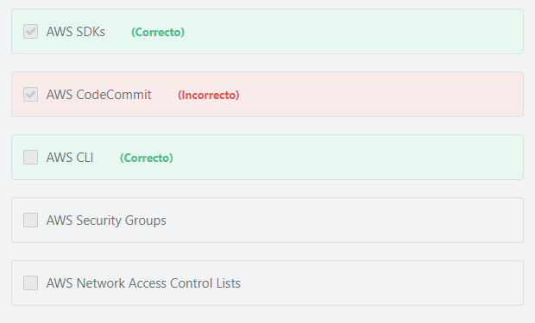Principio del formulario

**Explicación**

           Customers can work with AWS Identity and Access Management in any of the following ways:

1- AWS Management Console: The console is a browser-based interface that can be used to manage IAM and AWS resources.

2- AWS Command Line Tools:  Customers can use the AWS command line tools to issue commands at your system's command line to perform IAM and AWS tasks. Using the command line can be faster and more convenient than the console. The command line tools are also useful if you want to build scripts that perform AWS tasks.  AWS provides two sets of command line tools: the AWS Command Line Interface (AWS CLI) and the AWS Tools for Windows PowerShell.

3- AWS SDKs:  AWS provides SDKs (software development kits) that consist of libraries and sample code for various programming languages and platforms (Java, Python, Ruby, .NET, iOS, Android, etc.). The SDKs provide a convenient way to create programmatic access to IAM and AWS. For example, the SDKs take care of tasks such as cryptographically signing requests, managing errors, and retrying requests automatically.

***The other options are incorrect:***

***"AWS Security Groups" is incorrect.***You can use security groups to control the inbound and outbound traffic for your instances.

"***AWS*** ***Network Access Control Lists***" ***is incorrect.***Network Access Control Lists (NACLs) are used to provide fine-grained control of network traffic into and out of a subnet.

***"AWS CodeCommit" is incorrect.*** AWS CodeCommit is a source code control service that hosts secure Git-based repositories. AWS CodeCommit is designed for software developers who need a secure, reliable, and scalable source control system to store and version their code.

**References:**

<https://docs.aws.amazon.com/IAM/latest/UserGuide/introduction.html#intro-accessing>

Final del formulario

Principio del formulario

Pregunta 63:**Incorrecto**

**A company is planning to use Amazon S3 and Amazon CloudFront to distribute its video courses globally. What tool can the company use to estimate the costs of these services?**

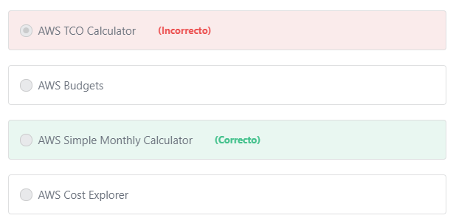

Final del formulario

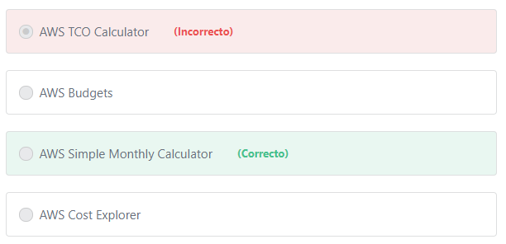Principio del formulario

**Explicación**

         The AWS Simple Monthly Calculator helps you estimate your monthly AWS bill more efficiently. The calculator can be used to determine your best and worst case scenarios and identify areas of development to reduce your monthly costs. The AWS Simple Monthly Calculator is continuously updated with the latest pricing for all AWS services in all Regions. The AWS Simple Monthly Calculator is available at: <https://calculator.s3.amazonaws.com/index.html>

***The other options are incorrect.***

***AWS Budgets" is incorrect.***AWS Budgets gives you the ability to set custom budgets that alert you when your costs or usage exceed (or are forecasted to exceed) your budgeted amount. You can also set up AWS Budgets to alert you when your reservation utilization drops below the threshold you define.

***"AWS TCO Calculator" is incorrect.***The AWS TCO calculator is used to compare the cost of running your applications in an on-premises or colocation environment to AWS. The TCO calculator matches your current infrastructure to the most cost effective AWS offering. This tool considers all the costs to run a solution in AWS, including physical facilities, power, and cooling, to provide a realistic, end-to-end comparison of your costs.

***"AWS Cost Explorer" is incorrect.***

       AWS Cost Explorer is used to explore and analyze your historical spend and usage. AWS Cost Explorer allows you to have visibility into your consumption patterns, such as, mapping the most commonly used services, and identifying unexpected anomalies or expenses.

       AWS Cost Explorer can also be used to estimate AWS services costs, but it calculates these estimates based on your previous AWS consumption (meaning AWS Cost Explorer is suitable for **existing projects only**). In the above scenario, AWS Simple Monthly Calculator is the right choice because it can be used to estimate the costs of **both existing and new projects** (in our case, it is a new project).

        AWS Simple Monthly Calculator enables you to estimate the monthly cost of AWS services for your use case based on your expected usage (not based on previous consumption as is the case with AWS Cost Explorer). For example, if you expect to use 500 GB of S3 Standard storage, you can simply enter this value in the appropriate field and the calculator provides an estimate of your monthly bill.

Additional information:

        AWS Cost Explorer Forecasting provides an estimate of what your AWS bill will be, based on your past usage. AWS Cost Explorer segments your historical data based on distinct charge types (e.g., on-demand usage, reserved instance usage, and more) and uses a combination of machine learning and rules-based models to predict spend across all of those charge types individually.

**References:**

<https://d1.awsstatic.com/whitepapers/aws_pricing_overview.pdf>    page 20

Final del formulario

Principio del formulario

Pregunta 64:**Correcto**

**​ What is the AWS Support feature that allows customers to manage support cases programmatically?**

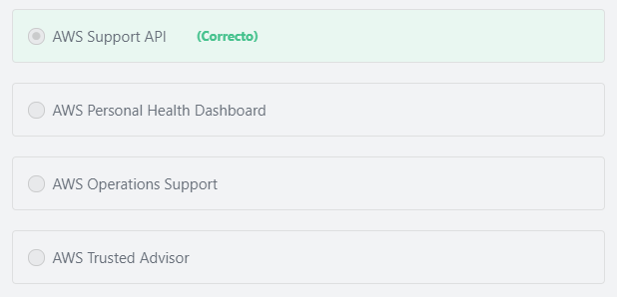

Final del formulario

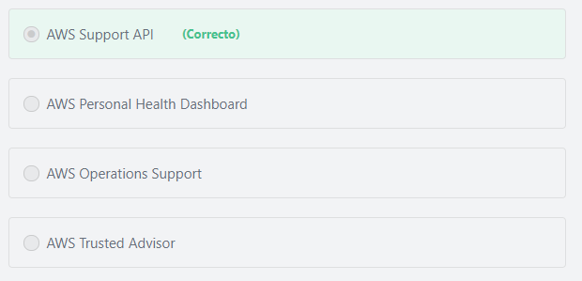Principio del formulario

**Explicación**

             The AWS Support API provides programmatic access to AWS Support Center features to create, manage, and close support cases, and operationally manage Trusted Advisor check requests and status. AWS provides access to AWS Support API for AWS Support customers who have a Business or Enterprise support plan.

The service currently provides two different groups of operations:

1- Support Case Management operations to manage the entire life cycle of AWS support cases, from creating a case to resolving it.

2- Trusted Advisor operations to access the checks provided by AWS Trusted Advisor.

***The other options are incorrect:***

***"AWS Trusted Advisor" is incorrect.***AWS Trusted Advisor analyzes AWS environments and provides best practice recommendations in five categories: cost optimization, security, fault tolerance, performance and service limits.

***"AWS Personal Health Dashboard" is incorrect.***AWS Personal Health Dashboard provides a view of the health of AWS services and resources that are used by a given AWS account.

***"AWS*** ***Operations Support" is incorrect.*** Included with the Enterprise support plan, Operations Support provides consultative reviews of your AWS operations and advice for optimization.

**References:**

<https://docs.aws.amazon.com/awssupport/latest/user/Welcome.html>

Final del formulario

Principio del formulario

Pregunta 65:**Incorrecto**

**Which of the following should be taken into account when performing a TCO analysis regarding the costs of running an application on AWS VS on-premises? (Choose TWO)**

Final del formulario

#### Explicación

             Weighing the financial considerations of owning and operating a data center facility versus employing a cloud infrastructure requires detailed and careful analysis. In practice, it is not as simple as just measuring potential hardware expense alongside utility pricing for compute and storage resources. The Total Cost of Ownership (TCO) is often the financial metric used to estimate and compare direct and indirect costs of a product or a service. Cooling and power consumption, data center space, data center real estate and Labor IT cost are examples of the indirect costs of a physical data center and should be included in TCO analysis.

**Additional information:**

Labor IT costs include the cost of the sizable IT infrastructure teams that are needed to handle the “heavy lifting” of managing physical infrastructure:

1- Hardware procurement teams are needed. These teams have to spend a lot of time evaluating hardware, negotiating contracts, holding hardware vendor meetings, managing delivery and installation, etc. It’s expensive to have a staff with sufficient knowledge to do this well.

2- Data center design and build teams are needed to create and maintain reliable and cost-effective facilities. These teams need to stay up-to-date on data center design and be experts in managing heterogeneous hardware and the related supply chain, managing legacy software, moving facilities, scaling and managing physical growth—all the tasks that an enterprise needs to do well if it wants to achieve low incremental costs.

3- Operations staff is needed 24/7/365 in each facility.

4- Database administration teams are needed to manage the databases. This staff is responsible for installing, patching, upgrades, migration, backups, snapshots and recovery of databases, ensuring availability, troubleshooting, and performance enhancements.

5- Networking teams are needed for running a highly available network. Expertise is needed to design, debug, scale, and operate the network and deal with the external relationships necessary to have cost-effective Internet transit.

6- Security personnel are needed at all phases of the design, build, and operations process.

**The other options are incorrect.**

**"Software compatibility" and "Software architecture" are incorrect.** In the scenario, the Total Cost of Ownership (TCO) is the total cost of owning and operating a data center, including facilities, physical servers, storage devices, networking equipment, cooling and power consumption, data center space, Labor, and IT costs. "Software compatibility" and "software architecture" are not part of the total cost of owning and operating a data center (TCO), and thus are incorrect answers.

**"Amazon EBS computing power" is incorrect.**Amazon EBS is a block storage service that creates volumes to be used by EC2 instances.

**References:**

<https://awstcocalculator.com/>

<https://aws.amazon.com/tco-calculator/>